20170309
# As I understood, to test configuration, needs to execute utility without key option “-f”.
# Like follow:
logrotate -v /etc/logrotate.conf

Check all configs.
[root@sdw1 ~]# logrotate -vf /etc/logrotate.conf
reading config file /etc/logrotate.conf
including /etc/logrotate.d
reading config file cups
reading config info for /var/log/cups/*_log
reading config file dracut
reading config info for /var/log/dracut.log
reading config file hpadureport
reading config info for /var/log/hpadureport.zip
reading config file psacct
reading config info for /var/account/pacct
reading config file sssd
reading config info for /var/log/sssd/*.log
reading config file subscription-manager
reading config info for /var/log/rhsm/*.log
reading config file syslog
reading config info for /var/log/cron
/var/log/maillog
/var/log/messages
/var/log/secure
/var/log/spooler

reading config file up2date
reading config info for /var/log/up2date
reading config file yum
reading config info for /var/log/yum.log
reading config info for /var/log/wtmp
reading config info for /var/log/btmp

Handling 11 logs

rotating pattern: /var/log/cups/*_log forced from command line (4 rotations)
empty log files are not rotated, old logs are removed
considering log /var/log/cups/*_log
log /var/log/cups/*_log does not exist -- skipping

rotating pattern: /var/log/dracut.log forced from command line (4 rotations)
empty log files are not rotated, old logs are removed
considering log /var/log/dracut.log
log does not need rotating

rotating pattern: /var/log/hpadureport.zip forced from command line (10 rotations)
empty log files are not rotated, old logs are removed
considering log /var/log/hpadureport.zip
log needs rotating
rotating log /var/log/hpadureport.zip, log->rotateCount is 10
dateext suffix '-20140115'
glob pattern '-[0-9][0-9][0-9][0-9][0-9][0-9][0-9][0-9]'
glob finding old rotated logs failed
renaming /var/log/hpadureport.zip to /var/log/hpadureport.zip-20140115
creating new /var/log/hpadureport.zip mode = 0644 uid = 0 gid = 0

rotating pattern: /var/account/pacct forced from command line (31 rotations)
empty log files are not rotated, old logs are removed
considering log /var/account/pacct
log does not need rotating
not running postrotate script, since no logs were rotated

rotating pattern: /var/log/sssd/*.log forced from command line (2 rotations)
empty log files are not rotated, old logs are removed
considering log /var/log/sssd/*.log
log /var/log/sssd/*.log does not exist -- skipping
not running postrotate script, since no logs were rotated

rotating pattern: /var/log/rhsm/*.log forced from command line (4 rotations)
empty log files are not rotated, old logs are removed
considering log /var/log/rhsm/rhsmcertd.log
log does not need rotating
considering log /var/log/rhsm/rhsm.log
log needs rotating
rotating log /var/log/rhsm/rhsm.log, log->rotateCount is 4
dateext suffix '-20140115'
glob pattern '-[0-9][0-9][0-9][0-9][0-9][0-9][0-9][0-9]'
renaming /var/log/rhsm/rhsm.log to /var/log/rhsm/rhsm.log-20140115
creating new /var/log/rhsm/rhsm.log mode = 0644 uid = 0 gid = 0
removing old log /var/log/rhsm/rhsm.log-20131222

rotating pattern: /var/log/cron
/var/log/maillog
/var/log/messages
/var/log/secure
/var/log/spooler
forced from command line (4 rotations)
empty log files are rotated, old logs are removed
considering log /var/log/cron
log needs rotating
considering log /var/log/maillog
log needs rotating
considering log /var/log/messages
log needs rotating
considering log /var/log/secure
log needs rotating
considering log /var/log/spooler
log needs rotating
rotating log /var/log/cron, log->rotateCount is 4
dateext suffix '-20140115'
glob pattern '-[0-9][0-9][0-9][0-9][0-9][0-9][0-9][0-9]'
rotating log /var/log/maillog, log->rotateCount is 4
dateext suffix '-20140115'
glob pattern '-[0-9][0-9][0-9][0-9][0-9][0-9][0-9][0-9]'
rotating log /var/log/messages, log->rotateCount is 4
dateext suffix '-20140115'
glob pattern '-[0-9][0-9][0-9][0-9][0-9][0-9][0-9][0-9]'
rotating log /var/log/secure, log->rotateCount is 4
dateext suffix '-20140115'
glob pattern '-[0-9][0-9][0-9][0-9][0-9][0-9][0-9][0-9]'
rotating log /var/log/spooler, log->rotateCount is 4
dateext suffix '-20140115'
glob pattern '-[0-9][0-9][0-9][0-9][0-9][0-9][0-9][0-9]'
renaming /var/log/cron to /var/log/cron-20140115
creating new /var/log/cron mode = 0600 uid = 0 gid = 0
renaming /var/log/maillog to /var/log/maillog-20140115
creating new /var/log/maillog mode = 0600 uid = 0 gid = 0
renaming /var/log/messages to /var/log/messages-20140115
creating new /var/log/messages mode = 0600 uid = 0 gid = 0
renaming /var/log/secure to /var/log/secure-20140115
creating new /var/log/secure mode = 0600 uid = 0 gid = 0
renaming /var/log/spooler to /var/log/spooler-20140115
creating new /var/log/spooler mode = 0600 uid = 0 gid = 0
running postrotate script
removing old log /var/log/cron-20131222
removing old log /var/log/maillog-20131222
removing old log /var/log/messages-20131222
removing old log /var/log/secure-20131222
removing old log /var/log/spooler-20131222

rotating pattern: /var/log/up2date forced from command line (4 rotations)
empty log files are rotated, old logs are removed
considering log /var/log/up2date
log /var/log/up2date does not exist -- skipping

rotating pattern: /var/log/yum.log forced from command line (4 rotations)
empty log files are not rotated, old logs are removed
considering log /var/log/yum.log
log does not need rotating

rotating pattern: /var/log/wtmp forced from command line (1 rotations)
empty log files are rotated, only log files >= 1048576 bytes are rotated, old logs are removed
considering log /var/log/wtmp
log needs rotating
rotating log /var/log/wtmp, log->rotateCount is 1
dateext suffix '-20140115'
glob pattern '-[0-9][0-9][0-9][0-9][0-9][0-9][0-9][0-9]'
glob finding old rotated logs failed
renaming /var/log/wtmp to /var/log/wtmp-20140115
creating new /var/log/wtmp mode = 0664 uid = 0 gid = 22

rotating pattern: /var/log/btmp forced from command line (1 rotations)
empty log files are rotated, old logs are removed
considering log /var/log/btmp
log needs rotating
rotating log /var/log/btmp, log->rotateCount is 1
dateext suffix '-20140115'
glob pattern '-[0-9][0-9][0-9][0-9][0-9][0-9][0-9][0-9]'
renaming /var/log/btmp to /var/log/btmp-20140115
creating new /var/log/btmp mode = 0600 uid = 0 gid = 22
removing old log /var/log/btmp-20140101
[root@sdw1 ~]#

Check direct file config
[root@sdw1 ~]# logrotate -vf /etc/logrotate.d/hpadureport

[root@sdw1 ~]# logrotate -vfd /etc/logrotate.d/hpadureport
reading config file /etc/logrotate.d/hpadureport
reading config info for /var/log/hpadureport.zip

Handling 1 logs

rotating pattern: /var/log/hpadureport.zip forced from command line (10 rotations)
empty log files are not rotated, old logs are removed
considering log /var/log/hpadureport.zip
log does not need rotating
[root@sdw1 ~]#

Force executing log rotation for one configuration file. This used for testing purposes.
[root@sdw1 ~]# logrotate -vfd /etc/logrotate.d/hpadureport
reading config file /etc/logrotate.d/hpadureport
reading config info for /var/log/hpadureport.zip

Handling 1 logs

rotating pattern: /var/log/hpadureport.zip forced from command line (10 rotations)
empty log files are not rotated, old logs are removed
considering log /var/log/hpadureport.zip
log does not need rotating
[root@sdw1 ~]#

20141219
Daily rotation with add YYYYMMDD suffix.

[root@ds-pr-mpi01 ~]# cat /etc/logrotate.d/tomcat
/opt/tomcat/logs/catalina.out {
copytruncate
daily
dateext
rotate 10
missingok
notifempty
compress
sharedscripts
}

[root@ds-pr-mpi01 ~]#

[root@ds-pr-mpi01 ~]# logrotate -vf /etc/logrotate.d/tomcat
reading config file /etc/logrotate.d/tomcat
reading config info for /opt/tomcat/logs/catalina.out

Handling 1 logs

rotating pattern: /opt/tomcat/logs/catalina.out forced from command line (10 rotations)
empty log files are not rotated, old logs are removed
considering log /opt/tomcat/logs/catalina.out
log needs rotating
rotating log /opt/tomcat/logs/catalina.out, log->rotateCount is 10
glob finding old rotated logs failed
copying /opt/tomcat/logs/catalina.out to /opt/tomcat/logs/catalina.out-20141219
truncating /opt/tomcat/logs/catalina.out
compressing log with: /bin/gzip
[root@ds-pr-mpi01 ~]#

As a result will get follow:
[root@ds-pr-mpi01 ~]# ls -Alh /opt/tomcat/logs/catalina.out*
-rw-rw-r-- 1 bpcmpi bpcmpi 4.9M Dec 19 18:23 /opt/tomcat/logs/catalina.out
-rw-rw-r-- 1 bpcmpi bpcmpi 608M Dec 14 03:04 /opt/tomcat/logs/catalina.out.1.gz
-rw-rw-r-- 1 bpcmpi bpcmpi 671M Dec 19 18:08 /opt/tomcat/logs/catalina.out-20141219.gz
-rw-rw-r-- 1 bpcmpi bpcmpi 528M Dec 7 03:03 /opt/tomcat/logs/catalina.out.2.gz
-rw-rw-r-- 1 bpcmpi bpcmpi 459M Nov 30 03:02 /opt/tomcat/logs/catalina.out.3.gz
-rw-rw-r-- 1 bpcmpi bpcmpi 708M Nov 23 03:06 /opt/tomcat/logs/catalina.out.4.gz
-rw-rw-r-- 1 bpcmpi bpcmpi 437M Nov 9 03:03 /opt/tomcat/logs/catalina.out.6.gz
[root@ds-pr-mpi01 ~]#

If file size equal to zero we will receive follow:
[root@m1-pr-mpi01 ~]# logrotate -vf /etc/logrotate.d/tomcat
reading config file /etc/logrotate.d/tomcat
reading config info for /opt/tomcat/logs/catalina.out

Handling 1 logs

rotating pattern: /opt/tomcat/logs/catalina.out forced from command line (10 rotations)
empty log files are not rotated, old logs are removed
considering log /opt/tomcat/logs/catalina.out
log does not need rotating
[root@m1-pr-mpi01 ~]#

#
# 20181218.
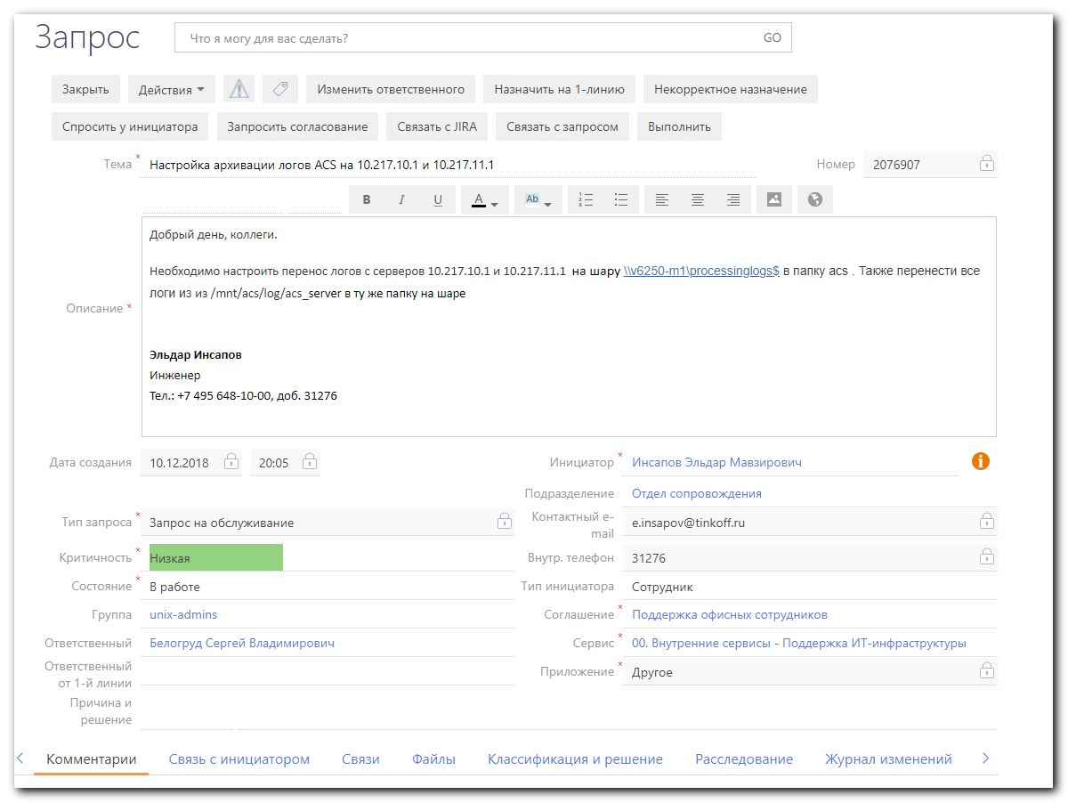
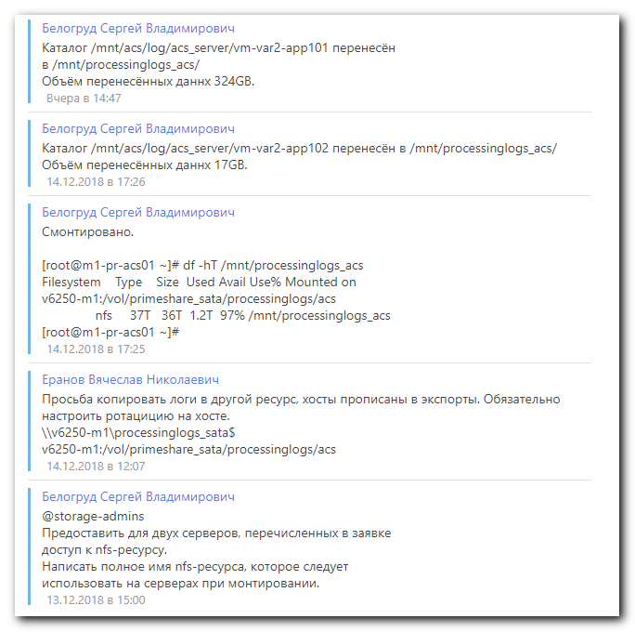
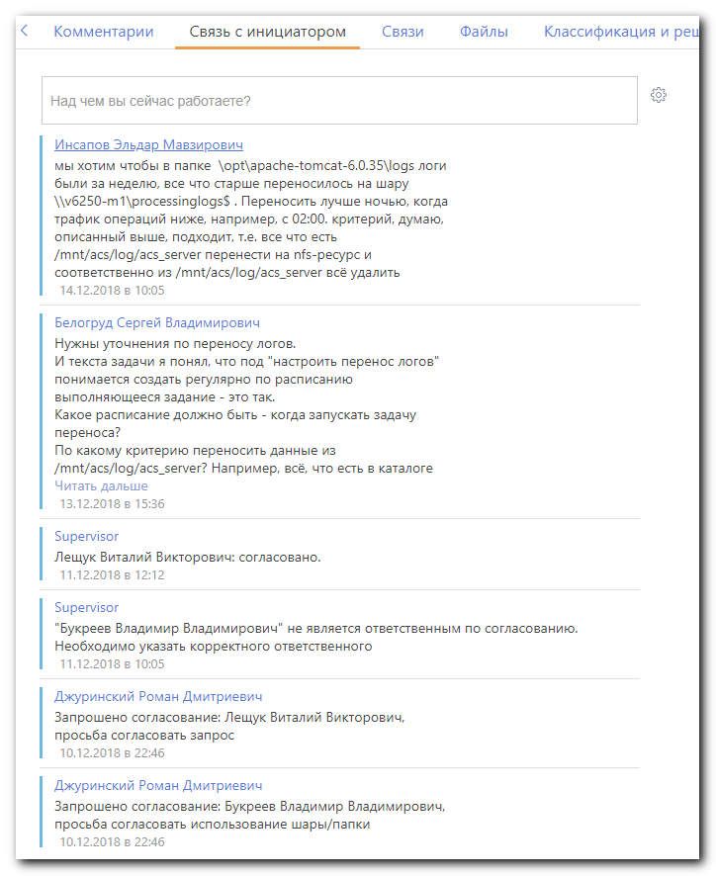
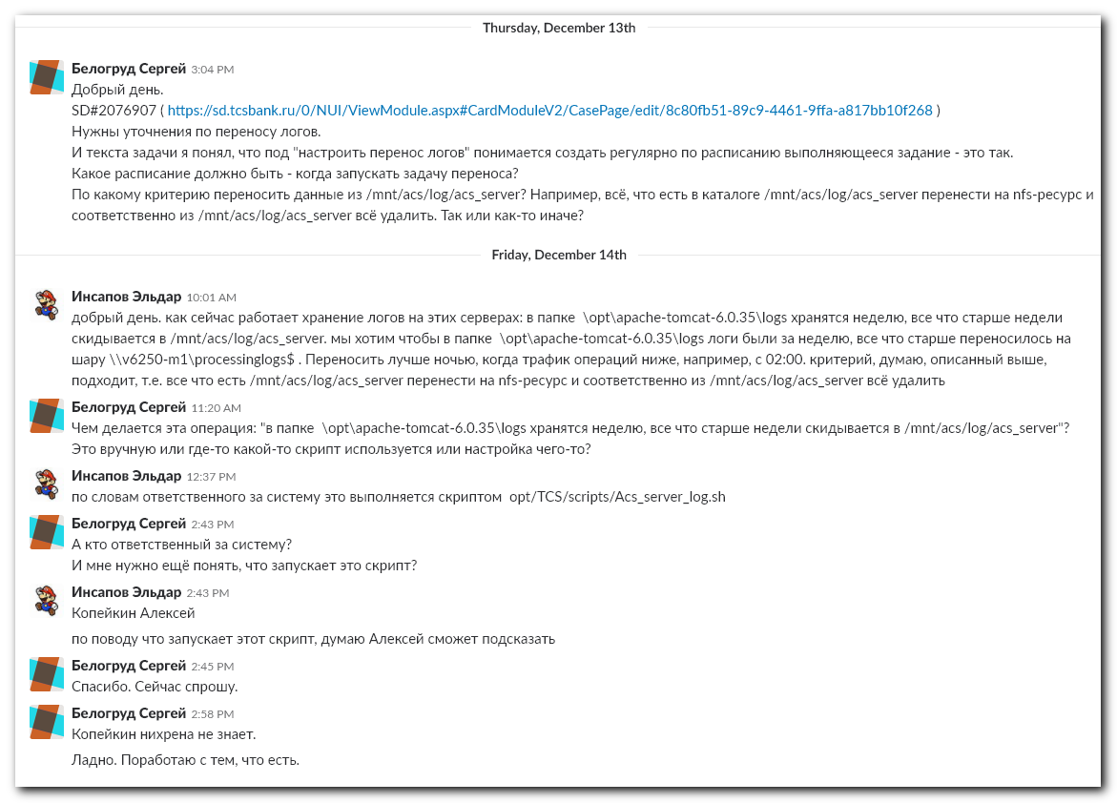
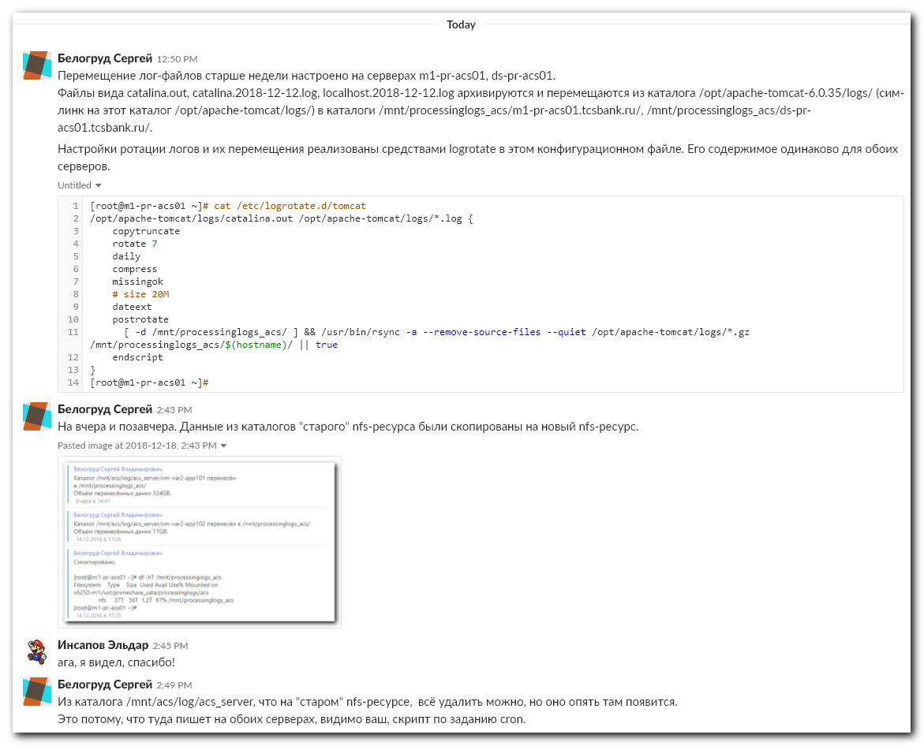
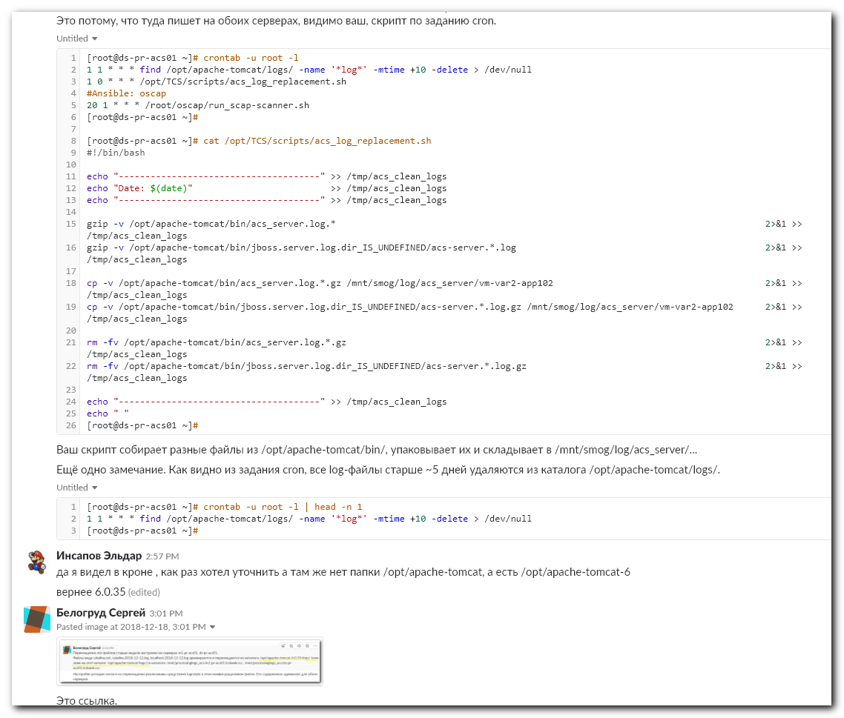
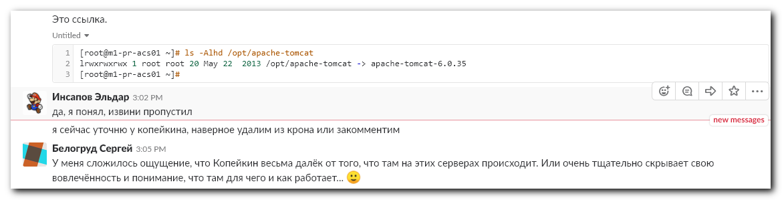

#
# https://www.tecmint.com/rsync-local-remote-file-synchronization-commands/
#

...........................................................................

[root@m1-pr-acs01 ~]# rsync -a /mnt/acs/log/acs_server/vm-var2-app102 /mnt/processinglogs_acs/
[root@m1-pr-acs01 ~]# rsync -a /mnt/acs/log/acs_server/vm-var2-app101 /mnt/processinglogs_acs/

[root@m1-pr-acs01 ~]# du -sh /mnt/processinglogs_acs/vm-var2-app101

...........................................................................

[root@m1-pr-acs01 ~]# cat /opt/TCS/scripts/acs_server_log.sh
#!/bin/bash

#LOGFILE="/opt/apache-tomcat-6.0.35/bin/acs_server.log.$(date +%d-%m-%Y)"
LOGFILE="/opt/apache-tomcat-6.0.35/bin/acs_server.log.25-11-2012"

if [[ -f $LOGFILE ]]; then
bzip2 -kv $LOGFILE
else
echo "File $LOGFILE does not exists. $(ls -la /opt/apache-tomcat-6.0.35/bin/)" | mail -s "ACS server $(hostname -a)" a.v.aleksandrov@tcsbank.ru
exit 1
fi

mount -t nfs | grep /mnt/smog

if [[ "$?" -ne 0 ]]; then
echo "/mnt/smog not mounted" | mail -s "ACS server $(hostname -a)" a.v.aleksandrov@tcsbank.ru
exit 1
fi

cp -v "$LOGFILE.bz2" /mnt/smog/log/acs_server/$(hostname -a)

if [[ "$?" -ne 0 ]]; then
echo "Can not copy $LOGFILE to /mnt/smog" | mail -s "ACS server $(hostname -a)" a.v.aleksandrov@tcsbank.ru
exit 1
fi

#rm -v "$LOGFILE.bz2"
[root@m1-pr-acs01 ~]#

...........................................................................

[root@ds-pr-acs01 ~]# ls -Alh /var/spool/cron/
total 4.0K
-rw------- 1 root root 194 Dec 12 15:30 root
[root@ds-pr-acs01 ~]# cat /var/spool/cron/root
1 1 * * * find /opt/apache-tomcat/logs/ -name '*log*' -mtime +10 -delete > /dev/null
1 0 * * * /opt/TCS/scripts/acs_log_replacement.sh
#Ansible: oscap
20 1 * * * /root/oscap/run_scap-scanner.sh
[root@ds-pr-acs01 ~]#

...........................................................................

[root@m1-pr-acs01 ~]# md5sum /opt/TCS/scripts/acs_server_log.sh
a5e8ac897eb17d98e14e25c4614293dd /opt/TCS/scripts/acs_server_log.sh
[root@m1-pr-acs01 ~]#

[root@ds-pr-acs01 ~]# md5sum /opt/TCS/scripts/acs_server_log.sh
a5e8ac897eb17d98e14e25c4614293dd /opt/TCS/scripts/acs_server_log.sh
[root@ds-pr-acs01 ~]#

...........................................................................

Белогруд Сергей [3:04 PM]
Добрый день.
SD#2076907 ( https://sd.tcsbank.ru/0/NUI/ViewModule.aspx#CardModuleV2/CasePage/edit/8c80fb51-89c9-4461-9ffa-a817bb10f268 )
Нужны уточнения по переносу логов.
И текста задачи я понял, что под "настроить перенос логов" понимается создать регулярно по расписанию выполняющееся задание - это так.
Какое расписание должно быть - когда запускать задачу переноса?
По какому критерию переносить данные из /mnt/acs/log/acs_server? Например, всё, что есть в каталоге /mnt/acs/log/acs_server перенести на nfs-ресурс и соответственно из /mnt/acs/log/acs_server всё удалить. Так или как-то иначе?

Инсапов Эльдар [10:01 AM]
добрый день. как сейчас работает хранение логов на этих серверах: в папке \opt\apache-tomcat-6.0.35\logs хранятся неделю, все что старше недели скидывается в /mnt/acs/log/acs_server. мы хотим чтобы в папке \opt\apache-tomcat-6.0.35\logs логи были за неделю, все что старше переносилось на шару \\v6250-m1\processinglogs$ . Переносить лучше ночью, когда трафик операций ниже, например, с 02:00. критерий, думаю, описанный выше, подходит, т.е. все что есть /mnt/acs/log/acs_server перенести на nfs-ресурс и соответственно из /mnt/acs/log/acs_server всё удалить

Белогруд Сергей [11:20 AM]
Чем делается эта операция: "в папке \opt\apache-tomcat-6.0.35\logs хранятся неделю, все что старше недели скидывается в /mnt/acs/log/acs_server"?
Это вручную или где-то какой-то скрипт используется или настройка чего-то?

Инсапов Эльдар [12:37 PM]
по словам ответственного за систему это выполняется скриптом opt/TCS/scripts/Acs_server_log.sh

Белогруд Сергей [2:43 PM]
А кто ответственный за систему?
И мне нужно ещё понять, что запускает это скрипт?

Инсапов Эльдар [2:43 PM]
Копейкин Алексей
по поводу что запускает этот скрипт, думаю Алексей сможет подсказать

Белогруд Сергей [2:45 PM]
Спасибо. Сейчас спрошу.

Белогруд Сергей [2:58 PM]
Копейкин нихрена не знает.
Ладно. Поработаю с тем, что есть.

...........................................................................

[root@ds-pr-acs01 ~]# ls -Alhd /opt/apache-tomcat/logs/
drwxrwxrwx 2 acs acs 4.0K Dec 16 01:01 /opt/apache-tomcat/logs/
[root@ds-pr-acs01 ~]# ls -Alhd \opt\apache-tomcat-6.0.35\logs
ls: cannot access optapache-tomcat-6.0.35logs: No such file or directory
[root@ds-pr-acs01 ~]#

[root@m1-pr-acs01 ~]# ls -Alhd /opt/apache-tomcat/logs/
drwxrwxrwx 2 acs acs 4.0K Dec 17 03:28 /opt/apache-tomcat/logs/
[root@m1-pr-acs01 ~]# ls -Alhd \opt\apache-tomcat-6.0.35\logs
ls: cannot access optapache-tomcat-6.0.35logs: No such file or directory
[root@m1-pr-acs01 ~]#

[root@m1-pr-acs01 ~]# ls -Ahd /opt/apache-tomcat-6.0.35/logs/
/opt/apache-tomcat-6.0.35/logs/
[root@m1-pr-acs01 ~]# ls -Ah /opt/apache-tomcat-6.0.35/logs/
catalina.2018-12-11.log catalina.2018-12-14.log catalina.2018-12-17.log catalina.out-20180516 catalina.out-20181213.gz catalina.out-20181216.gz localhost.2018-12-12.log localhost.2018-12-15.log
catalina.2018-12-12.log catalina.2018-12-15.log catalina.out catalina.out-20181211.gz catalina.out-20181214.gz catalina.out-20181217.gz localhost.2018-12-13.log localhost.2018-12-16.log
catalina.2018-12-13.log catalina.2018-12-16.log catalina.out-20151120 catalina.out-20181212.gz catalina.out-20181215.gz localhost.2018-12-11.log localhost.2018-12-14.log localhost.2018-12-17.log
[root@m1-pr-acs01 ~]#

[root@ds-pr-acs01 ~]# ls -Alh /opt/apache-tomcat-6.0.35/logs/
total 168M
-rw-r--r-- 1 acs acs 2.3K Dec 7 02:02 catalina.2018-12-07.log
-rw-r--r-- 1 acs acs 2.3K Dec 11 02:01 catalina.2018-12-11.log
-rw-r--r-- 1 acs acs 2.3K Dec 14 02:02 catalina.2018-12-14.log
-rw------- 1 acs acs 14M Dec 17 16:01 catalina.out
-rw------- 1 acs acs 26M Aug 8 03:50 catalina.out-20180808.gz
-rw------- 1 acs acs 22M Aug 9 03:49 catalina.out-20180809.gz
-rw------- 1 acs acs 2.7M Aug 20 03:17 catalina.out-20180820.gz
-rw------- 1 acs acs 2.8M Sep 7 03:25 catalina.out-20180907.gz
-rw------- 1 acs acs 2.4M Oct 6 03:39 catalina.out-20181006.gz
-rw------- 1 acs acs 2.6M Oct 23 03:33 catalina.out-20181023.gz
-rw------- 1 acs acs 19M Nov 21 03:45 catalina.out-20181121.gz
-rw-r--r-- 1 acs acs 58K Dec 11 14:15 localhost.2018-12-11.log
-rw-r--r-- 1 root root 15M Dec 13 2013 pareq
-rw-r--r-- 1 root root 66M Dec 13 2013 pares
[root@ds-pr-acs01 ~]#

...........................................................................

[root@m1-pr-acs01 ~]# md5sum /opt/TCS/scripts/acs_log_replacement.sh
77191e348415f3b1fe261c36ebf096c6 /opt/TCS/scripts/acs_log_replacement.sh
[root@m1-pr-acs01 ~]#

[root@m1-pr-acs01 ~]# cat /opt/TCS/scripts/acs_log_replacement.sh
#!/bin/bash

echo "--------------------------------------" >> /tmp/acs_clean_logs
echo "Date: $(date)" >> /tmp/acs_clean_logs
echo "--------------------------------------" >> /tmp/acs_clean_logs

gzip -v /opt/apache-tomcat/bin/jboss.server.log.dir_IS_UNDEFINED/acs-server.*.log 2>&1 >> /tmp/acs_clean_logs

cp -v /opt/apache-tomcat/bin/jboss.server.log.dir_IS_UNDEFINED/acs-server.*.log.gz /mnt/smog/log/acs_server/vm-var2-app101 2>&1 >> /tmp/acs_clean_logs

rm -fv /opt/apache-tomcat/bin/jboss.server.log.dir_IS_UNDEFINED/acs-server.*.log.gz 2>&1 >> /tmp/acs_clean_logs

echo "--------------------------------------" >> /tmp/acs_clean_logs
echo " "
[root@m1-pr-acs01 ~]#

[root@ds-pr-acs01 ~]# md5sum /opt/TCS/scripts/acs_log_replacement.sh
d08f50b60b256303a88f1909f5ecacdd /opt/TCS/scripts/acs_log_replacement.sh
[root@ds-pr-acs01 ~]#

[root@ds-pr-acs01 ~]# cat /opt/TCS/scripts/acs_log_replacement.sh
#!/bin/bash

echo "--------------------------------------" >> /tmp/acs_clean_logs
echo "Date: $(date)" >> /tmp/acs_clean_logs
echo "--------------------------------------" >> /tmp/acs_clean_logs

gzip -v /opt/apache-tomcat/bin/acs_server.log.* 2>&1 >> /tmp/acs_clean_logs
gzip -v /opt/apache-tomcat/bin/jboss.server.log.dir_IS_UNDEFINED/acs-server.*.log 2>&1 >> /tmp/acs_clean_logs

cp -v /opt/apache-tomcat/bin/acs_server.log.*.gz /mnt/smog/log/acs_server/vm-var2-app102 2>&1 >> /tmp/acs_clean_logs
cp -v /opt/apache-tomcat/bin/jboss.server.log.dir_IS_UNDEFINED/acs-server.*.log.gz /mnt/smog/log/acs_server/vm-var2-app102 2>&1 >> /tmp/acs_clean_logs

rm -fv /opt/apache-tomcat/bin/acs_server.log.*.gz 2>&1 >> /tmp/acs_clean_logs
rm -fv /opt/apache-tomcat/bin/jboss.server.log.dir_IS_UNDEFINED/acs-server.*.log.gz 2>&1 >> /tmp/acs_clean_logs

echo "--------------------------------------" >> /tmp/acs_clean_logs
echo " "
[root@ds-pr-acs01 ~]#

...........................................................................

[root@ds-pr-acs01 ~]# grep -irle "catalina" /etc/logrotate.*
/etc/logrotate.d/tomcat
[root@ds-pr-acs01 ~]# cat /etc/logrotate.d/tomcat
/opt/apache-tomcat/logs/catalina.out {
copytruncate
rotate 7
daily
compress
missingok
size 20M
}

[root@ds-pr-acs01 ~]#

[root@ds-pr-acs01 ~]# ls -Alhd /opt/apache-tomcat
lrwxrwxrwx 1 root root 20 May 22 2013 /opt/apache-tomcat -> apache-tomcat-6.0.35
[root@ds-pr-acs01 ~]#

[root@ds-pr-acs01 ~]# cat /etc/logrotate.conf
# see "man logrotate" for details
# rotate log files weekly
weekly

# keep 4 weeks worth of backlogs
rotate 4

# create new (empty) log files after rotating old ones
create

# use date as a suffix of the rotated file
dateext

# uncomment this if you want your log files compressed
#compress

# RPM packages drop log rotation information into this directory
include /etc/logrotate.d

# no packages own wtmp and btmp -- we'll rotate them here
/var/log/wtmp {
monthly
create 0664 root utmp
minsize 1M
rotate 1
}

/var/log/btmp {
missingok
monthly
create 0600 root utmp
rotate 1
}

# system-specific logs may be also be configured here.
[root@ds-pr-acs01 ~]#

...........................................................................

[root@ds-pr-acs01 ~]# grep -irle "postrotate" /etc/logrotate.*
/etc/logrotate.d/puppet
/etc/logrotate.d/named
/etc/logrotate.d/syslog
[root@ds-pr-acs01 ~]# cat /etc/logrotate.d/puppet
/var/log/puppet/*log {
missingok
notifempty
create 0644 puppet puppet
sharedscripts
postrotate
pkill -USR2 -u puppet -f 'puppet master' || true
[ -e /etc/init.d/puppet ] && /etc/init.d/puppet reload > /dev/null 2>&1 || true
endscript
}
[root@ds-pr-acs01 ~]#

[root@ds-pr-acs01 ~]# cat /etc/logrotate.d/named
/var/named/data/named.run {
missingok
create 0644 named named
postrotate
/sbin/service named reload 2> /dev/null > /dev/null || true
endscript
}
[root@ds-pr-acs01 ~]#

[root@ds-pr-acs01 ~]# cat /etc/logrotate.d/syslog
/var/log/cron
/var/log/maillog
/var/log/messages
/var/log/secure
/var/log/spooler
{
sharedscripts
postrotate
/bin/kill -HUP `cat /var/run/syslogd.pid 2> /dev/null` 2> /dev/null || true
endscript
}
[root@ds-pr-acs01 ~]#

...........................................................................

[root@ds-pr-acs01 ~]# logrotate -v /etc/logrotate.conf
reading config file /etc/logrotate.conf
including /etc/logrotate.d
reading config file atop
reading config info for /var/log/atop/atop.log
reading config file dracut
reading config info for /var/log/dracut.log
reading config file named
reading config info for /var/named/data/named.run
reading config file puppet
reading config info for /var/log/puppet/*log
reading config file subscription-manager
reading config info for /var/log/rhsm/*.log
reading config file syslog
reading config info for /var/log/cron
/var/log/maillog
/var/log/messages
/var/log/secure
/var/log/spooler

reading config file tomcat
reading config info for /opt/apache-tomcat/logs/catalina.out
reading config file up2date
reading config info for /var/log/up2date
reading config file yum
reading config info for /var/log/yum.log
reading config file zabbix-agent
reading config info for /var/log/zabbix/zabbix_agentd.log
reading config info for /var/log/wtmp
reading config info for /var/log/btmp

Handling 12 logs

rotating pattern: /var/log/atop/atop.log weekly (4 rotations)
empty log files are not rotated, old logs are removed
considering log /var/log/atop/atop.log
log /var/log/atop/atop.log does not exist -- skipping

rotating pattern: /var/log/dracut.log yearly (4 rotations)
empty log files are not rotated, old logs are removed
considering log /var/log/dracut.log
log does not need rotating

rotating pattern: /var/named/data/named.run weekly (4 rotations)
empty log files are rotated, old logs are removed
considering log /var/named/data/named.run
log does not need rotating
not running postrotate script, since no logs were rotated

rotating pattern: /var/log/puppet/*log weekly (4 rotations)
empty log files are not rotated, old logs are removed
considering log /var/log/puppet/puppet.log
log does not need rotating
not running postrotate script, since no logs were rotated

rotating pattern: /var/log/rhsm/*.log weekly (4 rotations)
empty log files are not rotated, old logs are removed
considering log /var/log/rhsm/rhsmcertd.log
log does not need rotating
considering log /var/log/rhsm/rhsm.log
log does not need rotating

rotating pattern: /var/log/cron
/var/log/maillog
/var/log/messages
/var/log/secure
/var/log/spooler
weekly (4 rotations)
empty log files are rotated, old logs are removed
considering log /var/log/cron
log does not need rotating
considering log /var/log/maillog
log does not need rotating
considering log /var/log/messages
log does not need rotating
considering log /var/log/secure
log does not need rotating
considering log /var/log/spooler
log does not need rotating
not running postrotate script, since no logs were rotated

rotating pattern: /opt/apache-tomcat/logs/catalina.out 20971520 bytes (7 rotations)
empty log files are rotated, old logs are removed
considering log /opt/apache-tomcat/logs/catalina.out
log does not need rotating
not running postrotate script, since no logs were rotated

rotating pattern: /var/log/up2date weekly (4 rotations)
empty log files are rotated, old logs are removed
considering log /var/log/up2date
log does not need rotating

rotating pattern: /var/log/yum.log yearly (4 rotations)
empty log files are not rotated, old logs are removed
considering log /var/log/yum.log
log does not need rotating

rotating pattern: /var/log/zabbix/zabbix_agentd.log weekly (12 rotations)
empty log files are not rotated, old logs are removed
considering log /var/log/zabbix/zabbix_agentd.log
log does not need rotating

rotating pattern: /var/log/wtmp monthly (1 rotations)
empty log files are rotated, only log files >= 1048576 bytes are rotated, old logs are removed
considering log /var/log/wtmp
log does not need rotating

rotating pattern: /var/log/btmp monthly (1 rotations)
empty log files are rotated, old logs are removed
considering log /var/log/btmp
log does not need rotating
[root@ds-pr-acs01 ~]#

#
# Here is what we want.
#
# rotating pattern: /opt/apache-tomcat/logs/catalina.out 20971520 bytes (7 rotations)
# empty log files are rotated, old logs are removed
# considering log /opt/apache-tomcat/logs/catalina.out
# log does not need rotating
# not running postrotate script, since no logs were rotated
#

................................................................................

[root@ds-pr-acs01 ~]# cat /etc/logrotate.d/tomcat
/opt/apache-tomcat/logs/catalina.out {
copytruncate
rotate 7
daily
compress
missingok
size 20M
dateext
postrotate
[ -d /mnt/processinglogs_acs/ ] && /usr/bin/rsync -a --delete --force /opt/apache-tomcat/logs/catalina.out*.gz /mnt/processinglogs_acs/$(hostname)/ || true
endscript
}
[root@ds-pr-acs01 ~]#

#
# This is only a test. Nothin will be done.
# For example a file /opt/apache-tomcat/logs/catalina.out-20180808.gz still in place. It was not removed.
#
[root@ds-pr-acs01 ~]# logrotate -vdf /etc/logrotate.d/tomcat
reading config file /etc/logrotate.d/tomcat
reading config info for /opt/apache-tomcat/logs/catalina.out

Handling 1 logs

rotating pattern: /opt/apache-tomcat/logs/catalina.out forced from command line (7 rotations)
empty log files are rotated, old logs are removed
considering log /opt/apache-tomcat/logs/catalina.out
log needs rotating
rotating log /opt/apache-tomcat/logs/catalina.out, log->rotateCount is 7
dateext suffix '-20181217'
glob pattern '-[0-9][0-9][0-9][0-9][0-9][0-9][0-9][0-9]'
copying /opt/apache-tomcat/logs/catalina.out to /opt/apache-tomcat/logs/catalina.out-20181217
truncating /opt/apache-tomcat/logs/catalina.out
running postrotate script
running script with arg /opt/apache-tomcat/logs/catalina.out: "
[ -d /mnt/processinglogs_acs/ ] && /usr/bin/rsync -a --delete --force /opt/apache-tomcat/logs/catalina.out*.gz /mnt/processinglogs_acs/$(hostname)/ || true
"
compressing log with: /bin/gzip
removing old log /opt/apache-tomcat/logs/catalina.out-20180808.gz
[root@ds-pr-acs01 ~]#

[root@ds-pr-acs01 ~]# ls -Alh /mnt/processinglogs_acs/
total 336K
drwxrwxrwx 2 root root 4.0K Dec 17 16:40 ds-pr-acs01.tcsbank.ru.backup
drwxrwxrwx 2 root root 4.0K Dec 17 16:38 m1-pr-acs01.tcsbank.ru
drwxrwxrwx 16 root root 4.0K Dec 17 14:01 .snapshot
drwxrwxrwx 2 root root 160K Dec 17 00:02 vm-var2-app101
drwxrwxrwx 2 root root 156K Dec 17 00:01 vm-var2-app102
[root@ds-pr-acs01 ~]# ls -Alh /opt/apache-tomcat/logs/
total 168M
-rw-r--r-- 1 acs acs 2.3K Dec 7 02:02 catalina.2018-12-07.log
-rw-r--r-- 1 acs acs 2.3K Dec 11 02:01 catalina.2018-12-11.log
-rw-r--r-- 1 acs acs 2.3K Dec 14 02:02 catalina.2018-12-14.log
-rw------- 1 acs acs 14M Dec 17 16:55 catalina.out
-rw------- 1 acs acs 26M Aug 8 03:50 catalina.out-20180808.gz
-rw------- 1 acs acs 22M Aug 9 03:49 catalina.out-20180809.gz
-rw------- 1 acs acs 2.7M Aug 20 03:17 catalina.out-20180820.gz
-rw------- 1 acs acs 2.8M Sep 7 03:25 catalina.out-20180907.gz
-rw------- 1 acs acs 2.4M Oct 6 03:39 catalina.out-20181006.gz
-rw------- 1 acs acs 2.6M Oct 23 03:33 catalina.out-20181023.gz
-rw------- 1 acs acs 19M Nov 21 03:45 catalina.out-20181121.gz
-rw-r--r-- 1 acs acs 58K Dec 11 14:15 localhost.2018-12-11.log
-rw-r--r-- 1 root root 15M Dec 13 2013 pareq
-rw-r--r-- 1 root root 66M Dec 13 2013 pares
[root@ds-pr-acs01 ~]#

................................................................................

#
# Here is a test again.
# Nothing was done.
#
[root@ds-pr-acs01 ~]# logrotate -df /etc/logrotate.d/tomcat
reading config file /etc/logrotate.d/tomcat
reading config info for /opt/apache-tomcat/logs/catalina.out

Handling 1 logs

rotating pattern: /opt/apache-tomcat/logs/catalina.out forced from command line (7 rotations)
empty log files are rotated, old logs are removed
considering log /opt/apache-tomcat/logs/catalina.out
log needs rotating
rotating log /opt/apache-tomcat/logs/catalina.out, log->rotateCount is 7
dateext suffix '-20181217'
glob pattern '-[0-9][0-9][0-9][0-9][0-9][0-9][0-9][0-9]'
copying /opt/apache-tomcat/logs/catalina.out to /opt/apache-tomcat/logs/catalina.out-20181217
truncating /opt/apache-tomcat/logs/catalina.out
running postrotate script
running script with arg /opt/apache-tomcat/logs/catalina.out: "
[ -d /mnt/processinglogs_acs/ ] && /usr/bin/rsync -a --delete --force /opt/apache-tomcat/logs/catalina.out*.gz /mnt/processinglogs_acs/$(hostname)/ || true
"
compressing log with: /bin/gzip
removing old log /opt/apache-tomcat/logs/catalina.out-20180808.gz
[root@ds-pr-acs01 ~]# ls -Alh /opt/apache-tomcat/logs/catalina.out-20180808.gz
-rw------- 1 acs acs 26M Aug 8 03:50 /opt/apache-tomcat/logs/catalina.out-20180808.gz
[root@ds-pr-acs01 ~]#

................................................................................

#
# At this moment something was done.
#

[root@ds-pr-acs01 ~]# logrotate -f /etc/logrotate.d/tomcat
[root@ds-pr-acs01 ~]#

[root@ds-pr-acs01 ~]# ls -Alh /opt/apache-tomcat/logs/
total 131M
-rw-r--r-- 1 acs acs 2.3K Dec 7 02:02 catalina.2018-12-07.log
-rw-r--r-- 1 acs acs 2.3K Dec 11 02:01 catalina.2018-12-11.log
-rw-r--r-- 1 acs acs 2.3K Dec 14 02:02 catalina.2018-12-14.log
-rw------- 1 acs acs 145 Dec 17 17:03 catalina.out
-rw------- 1 acs acs 22M Aug 9 03:49 catalina.out-20180809.gz
-rw------- 1 acs acs 2.7M Aug 20 03:17 catalina.out-20180820.gz
-rw------- 1 acs acs 2.8M Sep 7 03:25 catalina.out-20180907.gz
-rw------- 1 acs acs 2.4M Oct 6 03:39 catalina.out-20181006.gz
-rw------- 1 acs acs 2.6M Oct 23 03:33 catalina.out-20181023.gz
-rw------- 1 acs acs 19M Nov 21 03:45 catalina.out-20181121.gz
-rw------- 1 acs acs 1.6M Dec 17 17:03 catalina.out-20181217.gz
-rw-r--r-- 1 acs acs 58K Dec 11 14:15 localhost.2018-12-11.log
-rw-r--r-- 1 root root 15M Dec 13 2013 pareq
-rw-r--r-- 1 root root 66M Dec 13 2013 pares
[root@ds-pr-acs01 ~]# ls -Alh /mnt/processinglogs_acs/
total 340K
drwxrwxrwx 2 root root 4.0K Dec 17 17:03 ds-pr-acs01.tcsbank.ru
drwxrwxrwx 2 root root 4.0K Dec 17 16:40 ds-pr-acs01.tcsbank.ru.backup
drwxrwxrwx 2 root root 4.0K Dec 17 16:38 m1-pr-acs01.tcsbank.ru
drwxrwxrwx 16 root root 4.0K Dec 17 14:01 .snapshot
drwxrwxrwx 2 root root 160K Dec 17 00:02 vm-var2-app101
drwxrwxrwx 2 root root 156K Dec 17 00:01 vm-var2-app102
[root@ds-pr-acs01 ~]# ls -Alh /mnt/processinglogs_acs/ds-pr-acs01.tcsbank.ru/
total 76M
-rwxrwxrwx 1 root root 26M Aug 8 03:50 catalina.out-20180808.gz
-rwxrwxrwx 1 root root 22M Aug 9 03:49 catalina.out-20180809.gz
-rwxrwxrwx 1 root root 2.7M Aug 20 03:17 catalina.out-20180820.gz
-rwxrwxrwx 1 root root 2.8M Sep 7 03:25 catalina.out-20180907.gz
-rwxrwxrwx 1 root root 2.4M Oct 6 03:39 catalina.out-20181006.gz
-rwxrwxrwx 1 root root 2.6M Oct 23 03:33 catalina.out-20181023.gz
-rwxrwxrwx 1 root root 19M Nov 21 03:45 catalina.out-20181121.gz
[root@ds-pr-acs01 ~]#

................................................................................

[root@ds-pr-acs01 ~]# [ -d /mnt/processinglogs_acs/ ] && /usr/bin/rsync -a --remove-source-files --dry-run /opt/apache-tomcat/logs/catalina.out*.gz /mnt/processinglogs_acs/$(hostname)/ || true
[root@ds-pr-acs01 ~]#

[root@ds-pr-acs01 ~]# ls -Alh /mnt/processinglogs_acs/
total 340K
drwxrwxrwx 2 root root 4.0K Dec 17 16:40 ds-pr-acs01.tcsbank.ru.backup
drwxrwxrwx 2 root root 4.0K Dec 17 17:03 ds-pr-acs01.tcsbank.ru.backup.2
drwxrwxrwx 2 root root 4.0K Dec 17 16:38 m1-pr-acs01.tcsbank.ru
drwxrwxrwx 16 root root 4.0K Dec 17 14:01 .snapshot
drwxrwxrwx 2 root root 160K Dec 17 00:02 vm-var2-app101
drwxrwxrwx 2 root root 156K Dec 17 00:01 vm-var2-app102
[root@ds-pr-acs01 ~]#
[root@ds-pr-acs01 ~]# logrotate -vdf /etc/logrotate.d/tomcat
reading config file /etc/logrotate.d/tomcat
reading config info for /opt/apache-tomcat/logs/catalina.out

Handling 1 logs

rotating pattern: /opt/apache-tomcat/logs/catalina.out forced from command line (7 rotations)
empty log files are rotated, old logs are removed
considering log /opt/apache-tomcat/logs/catalina.out
log needs rotating
rotating log /opt/apache-tomcat/logs/catalina.out, log->rotateCount is 7
dateext suffix '-20181217'
glob pattern '-[0-9][0-9][0-9][0-9][0-9][0-9][0-9][0-9]'
destination /opt/apache-tomcat/logs/catalina.out-20181217.gz already exists, skipping rotation
[root@ds-pr-acs01 ~]#

................................................................................

[root@ds-pr-acs01 ~]# cat /etc/logrotate.d/tomcat
/opt/apache-tomcat/logs/catalina.out /opt/apache-tomcat/logs/*.log {
copytruncate
rotate 7
daily
compress
missingok
# size 20M
dateext
postrotate
[ -d /mnt/processinglogs_acs/ ] && /usr/bin/rsync -a --remove-source-files /opt/apache-tomcat/logs/catalina.out*.gz /mnt/processinglogs_acs/$(hostname)/ || true
endscript
}
[root@ds-pr-acs01 ~]#

[root@ds-pr-acs01 ~]# ls -Alh /mnt/processinglogs_acs/
total 340K
drwxrwxrwx 2 root root 4.0K Dec 17 16:40 ds-pr-acs01.tcsbank.ru.backup
drwxrwxrwx 2 root root 4.0K Dec 17 17:03 ds-pr-acs01.tcsbank.ru.backup.2
drwxrwxrwx 2 root root 4.0K Dec 17 16:38 m1-pr-acs01.tcsbank.ru.backup.1
drwxrwxrwx 16 root root 4.0K Dec 17 14:01 .snapshot
drwxrwxrwx 2 root root 160K Dec 17 00:02 vm-var2-app101
drwxrwxrwx 2 root root 156K Dec 17 00:01 vm-var2-app102
[root@ds-pr-acs01 ~]# logrotate -vdf /etc/logrotate.d/tomcat
reading config file /etc/logrotate.d/tomcat
reading config info for /opt/apache-tomcat/logs/catalina.out /opt/apache-tomcat/logs/*.log

Handling 1 logs

rotating pattern: /opt/apache-tomcat/logs/catalina.out /opt/apache-tomcat/logs/*.log forced from command line (7 rotations)
empty log files are rotated, old logs are removed
considering log /opt/apache-tomcat/logs/catalina.out
log needs rotating
considering log /opt/apache-tomcat/logs/catalina.2018-12-07.log
log needs rotating
considering log /opt/apache-tomcat/logs/catalina.2018-12-11.log
log needs rotating
considering log /opt/apache-tomcat/logs/catalina.2018-12-14.log
log needs rotating
considering log /opt/apache-tomcat/logs/localhost.2018-12-11.log
log needs rotating
rotating log /opt/apache-tomcat/logs/catalina.out, log->rotateCount is 7
dateext suffix '-20181217'
glob pattern '-[0-9][0-9][0-9][0-9][0-9][0-9][0-9][0-9]'
destination /opt/apache-tomcat/logs/catalina.out-20181217.gz already exists, skipping rotation
rotating log /opt/apache-tomcat/logs/catalina.2018-12-07.log, log->rotateCount is 7
dateext suffix '-20181217'
glob pattern '-[0-9][0-9][0-9][0-9][0-9][0-9][0-9][0-9]'
glob finding old rotated logs failed
copying /opt/apache-tomcat/logs/catalina.2018-12-07.log to /opt/apache-tomcat/logs/catalina.2018-12-07.log-20181217
truncating /opt/apache-tomcat/logs/catalina.2018-12-07.log
running postrotate script
running script with arg /opt/apache-tomcat/logs/catalina.2018-12-07.log: "
[ -d /mnt/processinglogs_acs/ ] && /usr/bin/rsync -a --remove-source-files /opt/apache-tomcat/logs/catalina.out*.gz /mnt/processinglogs_acs/$(hostname)/ || true
"
compressing log with: /bin/gzip
rotating log /opt/apache-tomcat/logs/catalina.2018-12-11.log, log->rotateCount is 7
dateext suffix '-20181217'
glob pattern '-[0-9][0-9][0-9][0-9][0-9][0-9][0-9][0-9]'
glob finding old rotated logs failed
copying /opt/apache-tomcat/logs/catalina.2018-12-11.log to /opt/apache-tomcat/logs/catalina.2018-12-11.log-20181217
truncating /opt/apache-tomcat/logs/catalina.2018-12-11.log
running postrotate script
running script with arg /opt/apache-tomcat/logs/catalina.2018-12-11.log: "
[ -d /mnt/processinglogs_acs/ ] && /usr/bin/rsync -a --remove-source-files /opt/apache-tomcat/logs/catalina.out*.gz /mnt/processinglogs_acs/$(hostname)/ || true
"
compressing log with: /bin/gzip
rotating log /opt/apache-tomcat/logs/catalina.2018-12-14.log, log->rotateCount is 7
dateext suffix '-20181217'
glob pattern '-[0-9][0-9][0-9][0-9][0-9][0-9][0-9][0-9]'
glob finding old rotated logs failed
copying /opt/apache-tomcat/logs/catalina.2018-12-14.log to /opt/apache-tomcat/logs/catalina.2018-12-14.log-20181217
truncating /opt/apache-tomcat/logs/catalina.2018-12-14.log
running postrotate script
running script with arg /opt/apache-tomcat/logs/catalina.2018-12-14.log: "
[ -d /mnt/processinglogs_acs/ ] && /usr/bin/rsync -a --remove-source-files /opt/apache-tomcat/logs/catalina.out*.gz /mnt/processinglogs_acs/$(hostname)/ || true
"
compressing log with: /bin/gzip
rotating log /opt/apache-tomcat/logs/localhost.2018-12-11.log, log->rotateCount is 7
dateext suffix '-20181217'
glob pattern '-[0-9][0-9][0-9][0-9][0-9][0-9][0-9][0-9]'
glob finding old rotated logs failed
copying /opt/apache-tomcat/logs/localhost.2018-12-11.log to /opt/apache-tomcat/logs/localhost.2018-12-11.log-20181217
truncating /opt/apache-tomcat/logs/localhost.2018-12-11.log
running postrotate script
running script with arg /opt/apache-tomcat/logs/localhost.2018-12-11.log: "
[ -d /mnt/processinglogs_acs/ ] && /usr/bin/rsync -a --remove-source-files /opt/apache-tomcat/logs/catalina.out*.gz /mnt/processinglogs_acs/$(hostname)/ || true
"
compressing log with: /bin/gzip
[root@ds-pr-acs01 ~]# logrotate -f /etc/logrotate.d/tomcat
rsync: link_stat "/opt/apache-tomcat/logs/catalina.out*.gz" failed: No such file or directory (2)
rsync error: some files/attrs were not transferred (see previous errors) (code 23) at main.c(1039) [sender=3.0.6]
rsync: link_stat "/opt/apache-tomcat/logs/catalina.out*.gz" failed: No such file or directory (2)
rsync error: some files/attrs were not transferred (see previous errors) (code 23) at main.c(1039) [sender=3.0.6]
rsync: link_stat "/opt/apache-tomcat/logs/catalina.out*.gz" failed: No such file or directory (2)
rsync error: some files/attrs were not transferred (see previous errors) (code 23) at main.c(1039) [sender=3.0.6]
[root@ds-pr-acs01 ~]#

[root@ds-pr-acs01 ~]# ls -Alh /mnt/processinglogs_acs/ds-pr-acs01.tcsbank.ru/
total 52M
-rwxrwxrwx 1 root root 22M Aug 9 03:49 catalina.out-20180809.gz
-rwxrwxrwx 1 root root 2.7M Aug 20 03:17 catalina.out-20180820.gz
-rwxrwxrwx 1 root root 2.8M Sep 7 03:25 catalina.out-20180907.gz
-rwxrwxrwx 1 root root 2.4M Oct 6 03:39 catalina.out-20181006.gz
-rwxrwxrwx 1 root root 2.6M Oct 23 03:33 catalina.out-20181023.gz
-rwxrwxrwx 1 root root 19M Nov 21 03:45 catalina.out-20181121.gz
-rwxrwxrwx 1 root root 1.6M Dec 17 17:03 catalina.out-20181217.gz
[root@ds-pr-acs01 ~]# ls -Alh /opt/apache-tomcat/logs/
total 80M
-rw-r--r-- 1 acs acs 0 Dec 17 17:32 catalina.2018-12-07.log
-rw-r--r-- 1 acs acs 358 Dec 17 17:33 catalina.2018-12-07.log-20181217.gz
-rw-r--r-- 1 acs acs 0 Dec 17 17:33 catalina.2018-12-11.log
-rw-r--r-- 1 acs acs 356 Dec 17 17:33 catalina.2018-12-11.log-20181217.gz
-rw-r--r-- 1 acs acs 0 Dec 17 17:33 catalina.2018-12-14.log
-rw-r--r-- 1 acs acs 356 Dec 17 17:33 catalina.2018-12-14.log-20181217.gz
-rw------- 1 acs acs 4.6K Dec 17 17:34 catalina.out
-rw-r--r-- 1 acs acs 0 Dec 17 17:33 localhost.2018-12-11.log
-rw-r--r-- 1 acs acs 1.8K Dec 17 17:33 localhost.2018-12-11.log-20181217.gz
-rw-r--r-- 1 root root 15M Dec 13 2013 pareq
-rw-r--r-- 1 root root 66M Dec 13 2013 pares
[root@ds-pr-acs01 ~]#

................................................................................

[root@ds-pr-acs01 ~]# vim /etc/logrotate.d/tomcat
[root@ds-pr-acs01 ~]# cat /etc/logrotate.d/tomcat
/opt/apache-tomcat/logs/catalina.out /opt/apache-tomcat/logs/*.log {
copytruncate
rotate 7
daily
compress
missingok
# size 20M
dateext
postrotate
[ -d /mnt/processinglogs_acs/ ] && /usr/bin/rsync -a --remove-source-files --quiet /opt/apache-tomcat/logs/*.gz /mnt/processinglogs_acs/$(hostname)/ || true
endscript
}
[root@ds-pr-acs01 ~]#

[root@ds-pr-acs01 ~]# ls -Alh /opt/apache-tomcat/logs/
total 80M
-rw-r--r-- 1 acs acs 0 Dec 17 17:32 catalina.2018-12-07.log
-rw-r--r-- 1 acs acs 358 Dec 17 17:33 catalina.2018-12-07.log-20181217.gz
-rw-r--r-- 1 acs acs 0 Dec 17 17:33 catalina.2018-12-11.log
-rw-r--r-- 1 acs acs 356 Dec 17 17:33 catalina.2018-12-11.log-20181217.gz
-rw-r--r-- 1 acs acs 0 Dec 17 17:33 catalina.2018-12-14.log
-rw-r--r-- 1 acs acs 356 Dec 17 17:33 catalina.2018-12-14.log-20181217.gz
-rw------- 1 acs acs 5.3K Dec 17 17:39 catalina.out
-rw-r--r-- 1 acs acs 0 Dec 17 17:33 localhost.2018-12-11.log
-rw-r--r-- 1 acs acs 1.8K Dec 17 17:33 localhost.2018-12-11.log-20181217.gz
-rw-r--r-- 1 root root 15M Dec 13 2013 pareq
-rw-r--r-- 1 root root 66M Dec 13 2013 pares
[root@ds-pr-acs01 ~]#

[root@ds-pr-acs01 ~]# mv /mnt/processinglogs_acs/ds-pr-acs01.tcsbank.ru{,.backup.3}
[root@ds-pr-acs01 ~]# ls -Alh /mnt/processinglogs_acs/
total 344K
drwxrwxrwx 2 root root 4.0K Dec 17 16:40 ds-pr-acs01.tcsbank.ru.backup
drwxrwxrwx 2 root root 4.0K Dec 17 17:03 ds-pr-acs01.tcsbank.ru.backup.2
drwxrwxrwx 2 root root 4.0K Dec 17 17:33 ds-pr-acs01.tcsbank.ru.backup.3
drwxrwxrwx 2 root root 4.0K Dec 17 16:38 m1-pr-acs01.tcsbank.ru.backup.1
drwxrwxrwx 16 root root 4.0K Dec 17 14:01 .snapshot
drwxrwxrwx 2 root root 160K Dec 17 00:02 vm-var2-app101
drwxrwxrwx 2 root root 156K Dec 17 00:01 vm-var2-app102
[root@ds-pr-acs01 ~]#

[root@ds-pr-acs01 ~]# ls -Alh /opt/apache-tomcat/logs/
total 80M
-rw-r--r-- 1 acs acs 0 Dec 17 17:41 catalina.2018-12-07.log
-rw-r--r-- 1 acs acs 0 Dec 17 17:41 catalina.2018-12-11.log
-rw-r--r-- 1 acs acs 0 Dec 17 17:41 catalina.2018-12-14.log
-rw------- 1 acs acs 145 Dec 17 17:41 catalina.out
-rw-r--r-- 1 acs acs 0 Dec 17 17:41 localhost.2018-12-11.log
-rw-r--r-- 1 acs acs 20 Dec 17 17:41 localhost.2018-12-11.log-20181217.gz
-rw-r--r-- 1 root root 15M Dec 13 2013 pareq
-rw-r--r-- 1 root root 66M Dec 13 2013 pares
[root@ds-pr-acs01 ~]#
[root@ds-pr-acs01 ~]# ls -Alh /mnt/processinglogs_acs/
total 348K
drwxrwxrwx 2 root root 4.0K Dec 17 17:41 ds-pr-acs01.tcsbank.ru
drwxrwxrwx 2 root root 4.0K Dec 17 16:40 ds-pr-acs01.tcsbank.ru.backup
drwxrwxrwx 2 root root 4.0K Dec 17 17:03 ds-pr-acs01.tcsbank.ru.backup.2
drwxrwxrwx 2 root root 4.0K Dec 17 17:33 ds-pr-acs01.tcsbank.ru.backup.3
drwxrwxrwx 2 root root 4.0K Dec 17 16:38 m1-pr-acs01.tcsbank.ru.backup.1
drwxrwxrwx 16 root root 4.0K Dec 17 14:01 .snapshot
drwxrwxrwx 2 root root 160K Dec 17 00:02 vm-var2-app101
drwxrwxrwx 2 root root 156K Dec 17 00:01 vm-var2-app102
[root@ds-pr-acs01 ~]#
[root@ds-pr-acs01 ~]# ls -Alh /mnt/processinglogs_acs/ds-pr-acs01.tcsbank.ru/
total 8.0K
-rwxrwxrwx 1 root root 20 Dec 17 17:41 catalina.2018-12-07.log-20181217.gz
-rwxrwxrwx 1 root root 20 Dec 17 17:41 catalina.2018-12-11.log-20181217.gz
-rwxrwxrwx 1 root root 20 Dec 17 17:41 catalina.2018-12-14.log-20181217.gz
-rwxrwxrwx 1 root root 365 Dec 17 17:41 catalina.out-20181217.gz
-rwxrwxrwx 1 root root 1.8K Dec 17 17:33 localhost.2018-12-11.log-20181217.gz
[root@ds-pr-acs01 ~]#

................................................................................
................................................................................
................................................................................

[root@m1-pr-acs01 ~]# cat /etc/logrotate.d/tomcat
/opt/apache-tomcat/logs/catalina.out /opt/apache-tomcat/logs/*.log {
copytruncate
rotate 7
daily
compress
missingok
# size 20M
dateext
postrotate
[ -d /mnt/processinglogs_acs/ ] && /usr/bin/rsync -a --remove-source-files --quiet /opt/apache-tomcat/logs/*.gz /mnt/processinglogs_acs/$(hostname)/ || true
endscript
}
[root@m1-pr-acs01 ~]#

[root@m1-pr-acs01 ~]# ls -Alh /opt/apache-tomcat/logs/
total 9.1G
-rw-r--r-- 1 acs acs 27K Dec 11 23:51 catalina.2018-12-11.log
-rw-r--r-- 1 acs acs 18K Dec 12 23:57 catalina.2018-12-12.log
-rw-r--r-- 1 acs acs 17K Dec 13 23:59 catalina.2018-12-13.log
-rw-r--r-- 1 acs acs 24K Dec 14 23:43 catalina.2018-12-14.log
-rw-r--r-- 1 acs acs 17K Dec 15 23:58 catalina.2018-12-15.log
-rw-r--r-- 1 acs acs 17K Dec 16 23:37 catalina.2018-12-16.log
-rw-r--r-- 1 acs acs 9.5K Dec 17 17:50 catalina.2018-12-17.log
-rw-r--r-- 1 acs root 2.1G Dec 17 17:52 catalina.out
-rw-r--r-- 1 acs acs 506M Nov 20 2015 catalina.out-20151120
-rw-r--r-- 1 acs acs 2.5G May 16 2018 catalina.out-20180516
-rw-r--r-- 1 acs root 633M Dec 11 03:13 catalina.out-20181211.gz
-rw-r--r-- 1 acs root 611M Dec 12 03:37 catalina.out-20181212.gz
-rw-r--r-- 1 acs root 605M Dec 13 03:17 catalina.out-20181213.gz
-rw-r--r-- 1 acs root 603M Dec 14 03:49 catalina.out-20181214.gz
-rw-r--r-- 1 acs root 651M Dec 15 03:29 catalina.out-20181215.gz
-rw-r--r-- 1 acs root 557M Dec 16 03:19 catalina.out-20181216.gz
-rw-r--r-- 1 acs root 525M Dec 17 03:28 catalina.out-20181217.gz
-rw-r--r-- 1 acs acs 976K Dec 11 23:59 localhost.2018-12-11.log
-rw-r--r-- 1 acs acs 922K Dec 12 23:59 localhost.2018-12-12.log
-rw-r--r-- 1 acs acs 935K Dec 13 23:59 localhost.2018-12-13.log
-rw-r--r-- 1 acs acs 936K Dec 14 23:58 localhost.2018-12-14.log
-rw-r--r-- 1 acs acs 779K Dec 15 23:59 localhost.2018-12-15.log
-rw-r--r-- 1 acs acs 790K Dec 16 23:59 localhost.2018-12-16.log
-rw-r--r-- 1 acs acs 643K Dec 17 17:51 localhost.2018-12-17.log
[root@m1-pr-acs01 ~]#

[root@m1-pr-acs01 ~]# ls -Alh /mnt/processinglogs_acs/
total 336K
drwxrwxrwx 2 root root 4.0K Dec 17 17:47 ds-pr-acs01.tcsbank.ru
drwxrwxrwx 2 root root 4.0K Dec 17 16:38 m1-pr-acs01.tcsbank.ru.backup.1
drwxrwxrwx 16 root root 4.0K Dec 17 14:01 .snapshot
drwxrwxrwx 2 root root 160K Dec 17 00:02 vm-var2-app101
drwxrwxrwx 2 root root 156K Dec 17 00:01 vm-var2-app102
[root@m1-pr-acs01 ~]#

................................................................................

#
# Daily cron jobs start after 3 AM.
# It fit for us.
#
Dec 17 03:27:01 m1-pr-acs01 run-parts(/etc/cron.daily)[16321]: starting etckeeper
Dec 17 03:27:01 m1-pr-acs01 run-parts(/etc/cron.daily)[16335]: finished etckeeper
Dec 17 03:27:01 m1-pr-acs01 run-parts(/etc/cron.daily)[16321]: starting logrotate
Dec 17 03:28:11 m1-pr-acs01 run-parts(/etc/cron.daily)[16399]: finished logrotate
Dec 17 03:28:11 m1-pr-acs01 run-parts(/etc/cron.daily)[16321]: starting mlocate.cron
Dec 17 03:28:11 m1-pr-acs01 run-parts(/etc/cron.daily)[16410]: finished mlocate.cron
Dec 17 03:28:11 m1-pr-acs01 run-parts(/etc/cron.daily)[16321]: starting rhsmd
Dec 17 03:28:12 m1-pr-acs01 run-parts(/etc/cron.daily)[16417]: finished rhsmd
Dec 17 03:28:12 m1-pr-acs01 anacron[14516]: Job `cron.daily' terminated (mailing output)
Dec 17 03:28:12 m1-pr-acs01 anacron[14516]: Normal exit (1 job run)

[root@m1-pr-acs01 ~]# cat /etc/anacrontab
# /etc/anacrontab: configuration file for anacron

# See anacron(8) and anacrontab(5) for details.

SHELL=/bin/sh
PATH=/sbin:/bin:/usr/sbin:/usr/bin
MAILTO=root
# the maximal random delay added to the base delay of the jobs
RANDOM_DELAY=45
# the jobs will be started during the following hours only
START_HOURS_RANGE=3-22

#period in days delay in minutes job-identifier command
1 5 cron.daily nice run-parts /etc/cron.daily
7 25 cron.weekly nice run-parts /etc/cron.weekly
@monthly 45 cron.monthly nice run-parts /etc/cron.monthly
[root@m1-pr-acs01 ~]#

[root@m1-pr-acs01 ~]# cat /etc/cron.hourly/0anacron
#!/bin/bash
#in case file doesn't exist
if test -r /var/spool/anacron/cron.daily; then
day=`cat /var/spool/anacron/cron.daily`
fi
if [ `date +%Y%m%d` = "$day" ]; then
exit 0;
fi

# in case anacron is already running,
# there will be log (daemon won't be running twice).
if test -x /usr/bin/on_ac_power; then
/usr/bin/on_ac_power &> /dev/null
if test $? -eq 1; then
exit 0
fi
fi
/usr/sbin/anacron -s
[root@m1-pr-acs01 ~]#

................................................................................
................................................................................

[root@m1-pr-acs01 ~]# ls -Alh /mnt/processinglogs_acs/m1-pr-acs01.tcsbank.ru/
total 4.8G
-rwxrwxrwx 1 root root 633M Dec 11 03:13 catalina.out-20181211.gz
-rwxrwxrwx 1 root root 611M Dec 12 03:37 catalina.out-20181212.gz
-rwxrwxrwx 1 root root 605M Dec 13 03:17 catalina.out-20181213.gz
-rwxrwxrwx 1 root root 603M Dec 14 03:49 catalina.out-20181214.gz
-rwxrwxrwx 1 root root 651M Dec 15 03:29 catalina.out-20181215.gz
-rwxrwxrwx 1 root root 557M Dec 16 03:19 catalina.out-20181216.gz
-rwxrwxrwx 1 root root 525M Dec 17 03:28 catalina.out-20181217.gz
-rwxrwxrwx 1 root root 629M Dec 18 03:10 catalina.out-20181218.gz
[root@m1-pr-acs01 ~]# ls -Alh /opt/apache-tomcat/logs/
total 3.7G
-rw-r--r-- 1 acs acs 18K Dec 12 23:57 catalina.2018-12-12.log
-rw-r--r-- 1 acs acs 17K Dec 13 23:59 catalina.2018-12-13.log
-rw-r--r-- 1 acs acs 24K Dec 14 23:43 catalina.2018-12-14.log
-rw-r--r-- 1 acs acs 17K Dec 15 23:58 catalina.2018-12-15.log
-rw-r--r-- 1 acs acs 17K Dec 16 23:37 catalina.2018-12-16.log
-rw-r--r-- 1 acs acs 14K Dec 17 23:26 catalina.2018-12-17.log
-rw-r--r-- 1 acs acs 11K Dec 18 10:34 catalina.2018-12-18.log
-rw-r--r-- 1 acs root 673M Dec 18 11:11 catalina.out
-rw-r--r-- 1 acs acs 506M Nov 20 2015 catalina.out-20151120
-rw-r--r-- 1 acs acs 2.5G May 16 2018 catalina.out-20180516
-rw-r--r-- 1 acs acs 922K Dec 12 23:59 localhost.2018-12-12.log
-rw-r--r-- 1 acs acs 935K Dec 13 23:59 localhost.2018-12-13.log
-rw-r--r-- 1 acs acs 936K Dec 14 23:58 localhost.2018-12-14.log
-rw-r--r-- 1 acs acs 779K Dec 15 23:59 localhost.2018-12-15.log
-rw-r--r-- 1 acs acs 790K Dec 16 23:59 localhost.2018-12-16.log
-rw-r--r-- 1 acs acs 992K Dec 17 23:59 localhost.2018-12-17.log
-rw-r--r-- 1 acs acs 249K Dec 18 11:11 localhost.2018-12-18.log
[root@m1-pr-acs01 ~]# cat /etc/logrotate.d/tomcat
/opt/apache-tomcat/logs/catalina.out /opt/apache-tomcat/logs/*.log {
copytruncate
rotate 7
daily
compress
missingok
# size 20M
dateext
postrotate
[ -d /mnt/processinglogs_acs/ ] && /usr/bin/rsync -a --remove-source-files --quiet /opt/apache-tomcat/logs/*.gz /mnt/processinglogs_acs/$(hostname)/ || true
endscript
}
[root@m1-pr-acs01 ~]# cat

................................................................................
................................................................................
................................................................................

[root@m1-pr-acs01 ~]# logrotate -vdf /etc/logrotate.d/tomcat
reading config file /etc/logrotate.d/tomcat
reading config info for /opt/apache-tomcat/logs/catalina.out /opt/apache-tomcat/logs/*.log

Handling 1 logs

rotating pattern: /opt/apache-tomcat/logs/catalina.out /opt/apache-tomcat/logs/*.log forced from command line (7 rotations)
empty log files are rotated, old logs are removed
considering log /opt/apache-tomcat/logs/catalina.out
log needs rotating
considering log /opt/apache-tomcat/logs/catalina.2018-12-12.log
log needs rotating
considering log /opt/apache-tomcat/logs/catalina.2018-12-13.log
log needs rotating
considering log /opt/apache-tomcat/logs/catalina.2018-12-14.log
log needs rotating
considering log /opt/apache-tomcat/logs/catalina.2018-12-15.log
log needs rotating
considering log /opt/apache-tomcat/logs/catalina.2018-12-16.log
log needs rotating
considering log /opt/apache-tomcat/logs/catalina.2018-12-17.log
log needs rotating
considering log /opt/apache-tomcat/logs/catalina.2018-12-18.log
log needs rotating
considering log /opt/apache-tomcat/logs/localhost.2018-12-12.log
log needs rotating
considering log /opt/apache-tomcat/logs/localhost.2018-12-13.log
log needs rotating
considering log /opt/apache-tomcat/logs/localhost.2018-12-14.log
log needs rotating
considering log /opt/apache-tomcat/logs/localhost.2018-12-15.log
log needs rotating
considering log /opt/apache-tomcat/logs/localhost.2018-12-16.log
log needs rotating
considering log /opt/apache-tomcat/logs/localhost.2018-12-17.log
log needs rotating
considering log /opt/apache-tomcat/logs/localhost.2018-12-18.log
log needs rotating
rotating log /opt/apache-tomcat/logs/catalina.out, log->rotateCount is 7
dateext suffix '-20181218'
glob pattern '-[0-9][0-9][0-9][0-9][0-9][0-9][0-9][0-9]'
glob finding old rotated logs failed
copying /opt/apache-tomcat/logs/catalina.out to /opt/apache-tomcat/logs/catalina.out-20181218
truncating /opt/apache-tomcat/logs/catalina.out
running postrotate script
running script with arg /opt/apache-tomcat/logs/catalina.out: "
[ -d /mnt/processinglogs_acs/ ] && /usr/bin/rsync -a --remove-source-files --quiet /opt/apache-tomcat/logs/*.gz /mnt/processinglogs_acs/$(hostname)/ || true
"
compressing log with: /bin/gzip
rotating log /opt/apache-tomcat/logs/catalina.2018-12-12.log, log->rotateCount is 7
dateext suffix '-20181218'
glob pattern '-[0-9][0-9][0-9][0-9][0-9][0-9][0-9][0-9]'
glob finding old rotated logs failed
copying /opt/apache-tomcat/logs/catalina.2018-12-12.log to /opt/apache-tomcat/logs/catalina.2018-12-12.log-20181218
truncating /opt/apache-tomcat/logs/catalina.2018-12-12.log
running postrotate script
running script with arg /opt/apache-tomcat/logs/catalina.2018-12-12.log: "
[ -d /mnt/processinglogs_acs/ ] && /usr/bin/rsync -a --remove-source-files --quiet /opt/apache-tomcat/logs/*.gz /mnt/processinglogs_acs/$(hostname)/ || true
"
compressing log with: /bin/gzip
rotating log /opt/apache-tomcat/logs/catalina.2018-12-13.log, log->rotateCount is 7
dateext suffix '-20181218'
glob pattern '-[0-9][0-9][0-9][0-9][0-9][0-9][0-9][0-9]'
glob finding old rotated logs failed
copying /opt/apache-tomcat/logs/catalina.2018-12-13.log to /opt/apache-tomcat/logs/catalina.2018-12-13.log-20181218
truncating /opt/apache-tomcat/logs/catalina.2018-12-13.log
running postrotate script
running script with arg /opt/apache-tomcat/logs/catalina.2018-12-13.log: "
[ -d /mnt/processinglogs_acs/ ] && /usr/bin/rsync -a --remove-source-files --quiet /opt/apache-tomcat/logs/*.gz /mnt/processinglogs_acs/$(hostname)/ || true
"
compressing log with: /bin/gzip
rotating log /opt/apache-tomcat/logs/catalina.2018-12-14.log, log->rotateCount is 7
dateext suffix '-20181218'
glob pattern '-[0-9][0-9][0-9][0-9][0-9][0-9][0-9][0-9]'
glob finding old rotated logs failed
copying /opt/apache-tomcat/logs/catalina.2018-12-14.log to /opt/apache-tomcat/logs/catalina.2018-12-14.log-20181218
truncating /opt/apache-tomcat/logs/catalina.2018-12-14.log
running postrotate script
running script with arg /opt/apache-tomcat/logs/catalina.2018-12-14.log: "
[ -d /mnt/processinglogs_acs/ ] && /usr/bin/rsync -a --remove-source-files --quiet /opt/apache-tomcat/logs/*.gz /mnt/processinglogs_acs/$(hostname)/ || true
"
compressing log with: /bin/gzip
rotating log /opt/apache-tomcat/logs/catalina.2018-12-15.log, log->rotateCount is 7
dateext suffix '-20181218'
glob pattern '-[0-9][0-9][0-9][0-9][0-9][0-9][0-9][0-9]'
glob finding old rotated logs failed
copying /opt/apache-tomcat/logs/catalina.2018-12-15.log to /opt/apache-tomcat/logs/catalina.2018-12-15.log-20181218
truncating /opt/apache-tomcat/logs/catalina.2018-12-15.log
running postrotate script
running script with arg /opt/apache-tomcat/logs/catalina.2018-12-15.log: "
[ -d /mnt/processinglogs_acs/ ] && /usr/bin/rsync -a --remove-source-files --quiet /opt/apache-tomcat/logs/*.gz /mnt/processinglogs_acs/$(hostname)/ || true
"
compressing log with: /bin/gzip
rotating log /opt/apache-tomcat/logs/catalina.2018-12-16.log, log->rotateCount is 7
dateext suffix '-20181218'
glob pattern '-[0-9][0-9][0-9][0-9][0-9][0-9][0-9][0-9]'
glob finding old rotated logs failed
copying /opt/apache-tomcat/logs/catalina.2018-12-16.log to /opt/apache-tomcat/logs/catalina.2018-12-16.log-20181218
truncating /opt/apache-tomcat/logs/catalina.2018-12-16.log
running postrotate script
running script with arg /opt/apache-tomcat/logs/catalina.2018-12-16.log: "
[ -d /mnt/processinglogs_acs/ ] && /usr/bin/rsync -a --remove-source-files --quiet /opt/apache-tomcat/logs/*.gz /mnt/processinglogs_acs/$(hostname)/ || true
"
compressing log with: /bin/gzip
rotating log /opt/apache-tomcat/logs/catalina.2018-12-17.log, log->rotateCount is 7
dateext suffix '-20181218'
glob pattern '-[0-9][0-9][0-9][0-9][0-9][0-9][0-9][0-9]'
glob finding old rotated logs failed
copying /opt/apache-tomcat/logs/catalina.2018-12-17.log to /opt/apache-tomcat/logs/catalina.2018-12-17.log-20181218
truncating /opt/apache-tomcat/logs/catalina.2018-12-17.log
running postrotate script
running script with arg /opt/apache-tomcat/logs/catalina.2018-12-17.log: "
[ -d /mnt/processinglogs_acs/ ] && /usr/bin/rsync -a --remove-source-files --quiet /opt/apache-tomcat/logs/*.gz /mnt/processinglogs_acs/$(hostname)/ || true
"
compressing log with: /bin/gzip
rotating log /opt/apache-tomcat/logs/catalina.2018-12-18.log, log->rotateCount is 7
dateext suffix '-20181218'
glob pattern '-[0-9][0-9][0-9][0-9][0-9][0-9][0-9][0-9]'
glob finding old rotated logs failed
copying /opt/apache-tomcat/logs/catalina.2018-12-18.log to /opt/apache-tomcat/logs/catalina.2018-12-18.log-20181218
truncating /opt/apache-tomcat/logs/catalina.2018-12-18.log
running postrotate script
running script with arg /opt/apache-tomcat/logs/catalina.2018-12-18.log: "
[ -d /mnt/processinglogs_acs/ ] && /usr/bin/rsync -a --remove-source-files --quiet /opt/apache-tomcat/logs/*.gz /mnt/processinglogs_acs/$(hostname)/ || true
"
compressing log with: /bin/gzip
rotating log /opt/apache-tomcat/logs/localhost.2018-12-12.log, log->rotateCount is 7
dateext suffix '-20181218'
glob pattern '-[0-9][0-9][0-9][0-9][0-9][0-9][0-9][0-9]'
glob finding old rotated logs failed
copying /opt/apache-tomcat/logs/localhost.2018-12-12.log to /opt/apache-tomcat/logs/localhost.2018-12-12.log-20181218
truncating /opt/apache-tomcat/logs/localhost.2018-12-12.log
running postrotate script
running script with arg /opt/apache-tomcat/logs/localhost.2018-12-12.log: "
[ -d /mnt/processinglogs_acs/ ] && /usr/bin/rsync -a --remove-source-files --quiet /opt/apache-tomcat/logs/*.gz /mnt/processinglogs_acs/$(hostname)/ || true
"
compressing log with: /bin/gzip
rotating log /opt/apache-tomcat/logs/localhost.2018-12-13.log, log->rotateCount is 7
dateext suffix '-20181218'
glob pattern '-[0-9][0-9][0-9][0-9][0-9][0-9][0-9][0-9]'
glob finding old rotated logs failed
copying /opt/apache-tomcat/logs/localhost.2018-12-13.log to /opt/apache-tomcat/logs/localhost.2018-12-13.log-20181218
truncating /opt/apache-tomcat/logs/localhost.2018-12-13.log
running postrotate script
running script with arg /opt/apache-tomcat/logs/localhost.2018-12-13.log: "
[ -d /mnt/processinglogs_acs/ ] && /usr/bin/rsync -a --remove-source-files --quiet /opt/apache-tomcat/logs/*.gz /mnt/processinglogs_acs/$(hostname)/ || true
"
compressing log with: /bin/gzip
rotating log /opt/apache-tomcat/logs/localhost.2018-12-14.log, log->rotateCount is 7
dateext suffix '-20181218'
glob pattern '-[0-9][0-9][0-9][0-9][0-9][0-9][0-9][0-9]'
glob finding old rotated logs failed
copying /opt/apache-tomcat/logs/localhost.2018-12-14.log to /opt/apache-tomcat/logs/localhost.2018-12-14.log-20181218
truncating /opt/apache-tomcat/logs/localhost.2018-12-14.log
running postrotate script
running script with arg /opt/apache-tomcat/logs/localhost.2018-12-14.log: "
[ -d /mnt/processinglogs_acs/ ] && /usr/bin/rsync -a --remove-source-files --quiet /opt/apache-tomcat/logs/*.gz /mnt/processinglogs_acs/$(hostname)/ || true
"
compressing log with: /bin/gzip
rotating log /opt/apache-tomcat/logs/localhost.2018-12-15.log, log->rotateCount is 7
dateext suffix '-20181218'
glob pattern '-[0-9][0-9][0-9][0-9][0-9][0-9][0-9][0-9]'
glob finding old rotated logs failed
copying /opt/apache-tomcat/logs/localhost.2018-12-15.log to /opt/apache-tomcat/logs/localhost.2018-12-15.log-20181218
truncating /opt/apache-tomcat/logs/localhost.2018-12-15.log
running postrotate script
running script with arg /opt/apache-tomcat/logs/localhost.2018-12-15.log: "
[ -d /mnt/processinglogs_acs/ ] && /usr/bin/rsync -a --remove-source-files --quiet /opt/apache-tomcat/logs/*.gz /mnt/processinglogs_acs/$(hostname)/ || true
"
compressing log with: /bin/gzip
rotating log /opt/apache-tomcat/logs/localhost.2018-12-16.log, log->rotateCount is 7
dateext suffix '-20181218'
glob pattern '-[0-9][0-9][0-9][0-9][0-9][0-9][0-9][0-9]'
glob finding old rotated logs failed
copying /opt/apache-tomcat/logs/localhost.2018-12-16.log to /opt/apache-tomcat/logs/localhost.2018-12-16.log-20181218
truncating /opt/apache-tomcat/logs/localhost.2018-12-16.log
running postrotate script
running script with arg /opt/apache-tomcat/logs/localhost.2018-12-16.log: "
[ -d /mnt/processinglogs_acs/ ] && /usr/bin/rsync -a --remove-source-files --quiet /opt/apache-tomcat/logs/*.gz /mnt/processinglogs_acs/$(hostname)/ || true
"
compressing log with: /bin/gzip
rotating log /opt/apache-tomcat/logs/localhost.2018-12-17.log, log->rotateCount is 7
dateext suffix '-20181218'
glob pattern '-[0-9][0-9][0-9][0-9][0-9][0-9][0-9][0-9]'
glob finding old rotated logs failed
copying /opt/apache-tomcat/logs/localhost.2018-12-17.log to /opt/apache-tomcat/logs/localhost.2018-12-17.log-20181218
truncating /opt/apache-tomcat/logs/localhost.2018-12-17.log
running postrotate script
running script with arg /opt/apache-tomcat/logs/localhost.2018-12-17.log: "
[ -d /mnt/processinglogs_acs/ ] && /usr/bin/rsync -a --remove-source-files --quiet /opt/apache-tomcat/logs/*.gz /mnt/processinglogs_acs/$(hostname)/ || true
"
compressing log with: /bin/gzip
rotating log /opt/apache-tomcat/logs/localhost.2018-12-18.log, log->rotateCount is 7
dateext suffix '-20181218'
glob pattern '-[0-9][0-9][0-9][0-9][0-9][0-9][0-9][0-9]'
glob finding old rotated logs failed
copying /opt/apache-tomcat/logs/localhost.2018-12-18.log to /opt/apache-tomcat/logs/localhost.2018-12-18.log-20181218
truncating /opt/apache-tomcat/logs/localhost.2018-12-18.log
running postrotate script
running script with arg /opt/apache-tomcat/logs/localhost.2018-12-18.log: "
[ -d /mnt/processinglogs_acs/ ] && /usr/bin/rsync -a --remove-source-files --quiet /opt/apache-tomcat/logs/*.gz /mnt/processinglogs_acs/$(hostname)/ || true
"
compressing log with: /bin/gzip
[root@m1-pr-acs01 ~]# logrotate -v /etc/logrotate.d/tomcat
reading config file /etc/logrotate.d/tomcat
reading config info for /opt/apache-tomcat/logs/catalina.out /opt/apache-tomcat/logs/*.log

Handling 1 logs

rotating pattern: /opt/apache-tomcat/logs/catalina.out /opt/apache-tomcat/logs/*.log after 1 days (7 rotations)
empty log files are rotated, old logs are removed
considering log /opt/apache-tomcat/logs/catalina.out
log does not need rotating
considering log /opt/apache-tomcat/logs/catalina.2018-12-12.log
log does not need rotating
considering log /opt/apache-tomcat/logs/catalina.2018-12-13.log
log does not need rotating
considering log /opt/apache-tomcat/logs/catalina.2018-12-14.log
log does not need rotating
considering log /opt/apache-tomcat/logs/catalina.2018-12-15.log
log does not need rotating
considering log /opt/apache-tomcat/logs/catalina.2018-12-16.log
log does not need rotating
considering log /opt/apache-tomcat/logs/catalina.2018-12-17.log
log does not need rotating
considering log /opt/apache-tomcat/logs/catalina.2018-12-18.log
log does not need rotating
considering log /opt/apache-tomcat/logs/localhost.2018-12-12.log
log does not need rotating
considering log /opt/apache-tomcat/logs/localhost.2018-12-13.log
log does not need rotating
considering log /opt/apache-tomcat/logs/localhost.2018-12-14.log
log does not need rotating
considering log /opt/apache-tomcat/logs/localhost.2018-12-15.log
log does not need rotating
considering log /opt/apache-tomcat/logs/localhost.2018-12-16.log
log does not need rotating
considering log /opt/apache-tomcat/logs/localhost.2018-12-17.log
log does not need rotating
considering log /opt/apache-tomcat/logs/localhost.2018-12-18.log
log does not need rotating
not running postrotate script, since no logs were rotated
not running postrotate script, since no logs were rotated
not running postrotate script, since no logs were rotated
not running postrotate script, since no logs were rotated
not running postrotate script, since no logs were rotated
not running postrotate script, since no logs were rotated
not running postrotate script, since no logs were rotated
not running postrotate script, since no logs were rotated
not running postrotate script, since no logs were rotated
not running postrotate script, since no logs were rotated
not running postrotate script, since no logs were rotated
not running postrotate script, since no logs were rotated
not running postrotate script, since no logs were rotated
not running postrotate script, since no logs were rotated
not running postrotate script, since no logs were rotated
[root@m1-pr-acs01 ~]# logrotate -f /etc/logrotate.d/tomcat
rsync: link_stat "/opt/apache-tomcat/logs/*.gz" failed: No such file or directory (2)
rsync error: some files/attrs were not transferred (see previous errors) (code 23) at main.c(1039) [sender=3.0.6]
[root@m1-pr-acs01 ~]#
[root@m1-pr-acs01 ~]# ls -Alh /mnt/processinglogs_acs/m1-pr-acs01.tcsbank.ru/
total 4.3G
-rwxrwxrwx 1 root root 728 Dec 18 12:26 catalina.2018-12-12.log-20181218.gz
-rwxrwxrwx 1 root root 675 Dec 18 12:26 catalina.2018-12-13.log-20181218.gz
-rwxrwxrwx 1 root root 1.2K Dec 18 12:26 catalina.2018-12-14.log-20181218.gz
-rwxrwxrwx 1 root root 681 Dec 18 12:27 catalina.2018-12-15.log-20181218.gz
-rwxrwxrwx 1 root root 712 Dec 18 12:27 catalina.2018-12-16.log-20181218.gz
-rwxrwxrwx 1 root root 609 Dec 18 12:27 catalina.2018-12-17.log-20181218.gz
-rwxrwxrwx 1 root root 927 Dec 18 12:27 catalina.2018-12-18.log-20181218.gz
-rwxrwxrwx 1 root root 633M Dec 11 03:13 catalina.out-20181211.gz
-rwxrwxrwx 1 root root 611M Dec 12 03:37 catalina.out-20181212.gz
-rwxrwxrwx 1 root root 605M Dec 13 03:17 catalina.out-20181213.gz
-rwxrwxrwx 1 root root 603M Dec 14 03:49 catalina.out-20181214.gz
-rwxrwxrwx 1 root root 651M Dec 15 03:29 catalina.out-20181215.gz
-rwxrwxrwx 1 root root 557M Dec 16 03:19 catalina.out-20181216.gz
-rwxrwxrwx 1 root root 525M Dec 17 03:28 catalina.out-20181217.gz
-rwxrwxrwx 1 root root 177M Dec 18 12:26 catalina.out-20181218.gz
-rwxrwxrwx 1 root root 22K Dec 18 12:27 localhost.2018-12-12.log-20181218.gz
-rwxrwxrwx 1 root root 24K Dec 18 12:27 localhost.2018-12-13.log-20181218.gz
-rwxrwxrwx 1 root root 23K Dec 18 12:27 localhost.2018-12-14.log-20181218.gz
-rwxrwxrwx 1 root root 19K Dec 18 12:27 localhost.2018-12-15.log-20181218.gz
-rwxrwxrwx 1 root root 20K Dec 18 12:27 localhost.2018-12-16.log-20181218.gz
-rwxrwxrwx 1 root root 25K Dec 18 12:27 localhost.2018-12-17.log-20181218.gz
[root@m1-pr-acs01 ~]# ls -Alh /opt/apache-tomcat/logs/
total 3.0G
-rw-r--r-- 1 acs acs 0 Dec 18 12:26 catalina.2018-12-12.log
-rw-r--r-- 1 acs acs 0 Dec 18 12:26 catalina.2018-12-13.log
-rw-r--r-- 1 acs acs 0 Dec 18 12:26 catalina.2018-12-14.log
-rw-r--r-- 1 acs acs 0 Dec 18 12:26 catalina.2018-12-15.log
-rw-r--r-- 1 acs acs 0 Dec 18 12:27 catalina.2018-12-16.log
-rw-r--r-- 1 acs acs 0 Dec 18 12:27 catalina.2018-12-17.log
-rw-r--r-- 1 acs acs 0 Dec 18 12:27 catalina.2018-12-18.log
-rw-r--r-- 1 acs root 7.5M Dec 18 12:28 catalina.out
-rw-r--r-- 1 acs acs 506M Nov 20 2015 catalina.out-20151120
-rw-r--r-- 1 acs acs 2.5G May 16 2018 catalina.out-20180516
-rw-r--r-- 1 acs acs 0 Dec 18 12:27 localhost.2018-12-12.log
-rw-r--r-- 1 acs acs 0 Dec 18 12:27 localhost.2018-12-13.log
-rw-r--r-- 1 acs acs 0 Dec 18 12:27 localhost.2018-12-14.log
-rw-r--r-- 1 acs acs 0 Dec 18 12:27 localhost.2018-12-15.log
-rw-r--r-- 1 acs acs 0 Dec 18 12:27 localhost.2018-12-16.log
-rw-r--r-- 1 acs acs 0 Dec 18 12:27 localhost.2018-12-17.log
-rw-r--r-- 1 acs acs 1.4K Dec 18 12:28 localhost.2018-12-18.log
-rw-r--r-- 1 acs acs 7.6K Dec 18 12:27 localhost.2018-12-18.log-20181218.gz
[root@m1-pr-acs01 ~]# cat /etc/logrotate.d/tomcat
/opt/apache-tomcat/logs/catalina.out /opt/apache-tomcat/logs/*.log {
copytruncate
rotate 7
daily
compress
missingok
# size 20M
dateext
postrotate
[ -d /mnt/processinglogs_acs/ ] && /usr/bin/rsync -a --remove-source-files --quiet /opt/apache-tomcat/logs/*.gz /mnt/processinglogs_acs/$(hostname)/ || true
endscript
}
[root@m1-pr-acs01 ~]#

#
# files in /opt/apache-tomcat/logs/
# catalina.2018-12-12.log and localhost.2018-12-12.log have 0 size, so it was not rsynced because it was not compressed because it were not rotated.
#
................................................................................

#
# 20181218
# At this moment we have follow files in rotated dirs:
#

[root@m1-pr-acs01 ~]# ls -Alh /opt/apache-tomcat/logs/
total 2.5G
-rw-r--r-- 1 acs acs 0 Dec 18 12:26 catalina.2018-12-12.log
-rw-r--r-- 1 acs acs 0 Dec 18 12:26 catalina.2018-12-13.log
-rw-r--r-- 1 acs acs 0 Dec 18 12:26 catalina.2018-12-14.log
-rw-r--r-- 1 acs acs 0 Dec 18 12:26 catalina.2018-12-15.log
-rw-r--r-- 1 acs acs 0 Dec 18 12:27 catalina.2018-12-16.log
-rw-r--r-- 1 acs acs 0 Dec 18 12:27 catalina.2018-12-17.log
-rw-r--r-- 1 acs acs 177 Dec 18 12:28 catalina.2018-12-18.log
-rw-r--r-- 1 acs root 30M Dec 18 12:34 catalina.out
-rw-r--r-- 1 acs acs 2.5G May 16 2018 catalina.out-20180516
-rw-r--r-- 1 acs acs 0 Dec 18 12:27 localhost.2018-12-12.log
-rw-r--r-- 1 acs acs 0 Dec 18 12:27 localhost.2018-12-13.log
-rw-r--r-- 1 acs acs 0 Dec 18 12:27 localhost.2018-12-14.log
-rw-r--r-- 1 acs acs 0 Dec 18 12:27 localhost.2018-12-15.log
-rw-r--r-- 1 acs acs 0 Dec 18 12:27 localhost.2018-12-16.log
-rw-r--r-- 1 acs acs 0 Dec 18 12:27 localhost.2018-12-17.log
-rw-r--r-- 1 acs acs 8.7K Dec 18 12:34 localhost.2018-12-18.log
-rw-r--r-- 1 acs acs 7.6K Dec 18 12:27 localhost.2018-12-18.log-20181218.gz
[root@m1-pr-acs01 ~]#

[root@ds-pr-acs01 ~]# ls -Alh /opt/apache-tomcat/logs/
total 80M
-rw-r--r-- 1 acs acs 0 Dec 18 03:21 catalina.2018-12-07.log
-rw-r--r-- 1 acs acs 0 Dec 18 03:21 catalina.2018-12-11.log
-rw-r--r-- 1 acs acs 0 Dec 18 03:21 catalina.2018-12-14.log
-rw-r--r-- 1 acs acs 5.4K Dec 18 02:03 catalina.2018-12-18.log
-rw------- 1 acs acs 86K Dec 18 12:34 catalina.out
-rw-r--r-- 1 acs acs 0 Dec 18 03:21 localhost.2018-12-11.log
-rw-r--r-- 1 acs acs 20 Dec 18 03:21 localhost.2018-12-11.log-20181218.gz
-rw-r--r-- 1 root root 15M Dec 13 2013 pareq
-rw-r--r-- 1 root root 66M Dec 13 2013 pares
[root@ds-pr-acs01 ~]#

#
# On remote nfs-resource we have follow directories.
#
[root@m1-pr-acs01 ~]# ls -Alh /mnt/processinglogs_acs/
total 336K
drwxrwxrwx 2 root root 4.0K Dec 18 03:21 ds-pr-acs01.tcsbank.ru
drwxrwxrwx 2 root root 4.0K Dec 18 12:34 m1-pr-acs01.tcsbank.ru
drwxrwxrwx 16 root root 4.0K Dec 18 06:00 .snapshot
drwxrwxrwx 2 root root 160K Dec 17 00:02 vm-var2-app101
drwxrwxrwx 2 root root 156K Dec 17 00:01 vm-var2-app102
[root@m1-pr-acs01 ~]#

#
# And we have follow archived files in remote nfs-resource.
#
[root@m1-pr-acs01 ~]# ls -Alh /mnt/processinglogs_acs/m1-pr-acs01.tcsbank.ru/
total 4.4G
-rwxrwxrwx 1 root root 728 Dec 18 12:26 catalina.2018-12-12.log-20181218.gz
-rwxrwxrwx 1 root root 675 Dec 18 12:26 catalina.2018-12-13.log-20181218.gz
-rwxrwxrwx 1 root root 1.2K Dec 18 12:26 catalina.2018-12-14.log-20181218.gz
-rwxrwxrwx 1 root root 681 Dec 18 12:27 catalina.2018-12-15.log-20181218.gz
-rwxrwxrwx 1 root root 712 Dec 18 12:27 catalina.2018-12-16.log-20181218.gz
-rwxrwxrwx 1 root root 609 Dec 18 12:27 catalina.2018-12-17.log-20181218.gz
-rwxrwxrwx 1 root root 927 Dec 18 12:27 catalina.2018-12-18.log-20181218.gz
-rwxrwxrwx 1 root root 89M Nov 20 2015 catalina.out-20151120.gz
-rwxrwxrwx 1 root root 633M Dec 11 03:13 catalina.out-20181211.gz
-rwxrwxrwx 1 root root 611M Dec 12 03:37 catalina.out-20181212.gz
-rwxrwxrwx 1 root root 605M Dec 13 03:17 catalina.out-20181213.gz
-rwxrwxrwx 1 root root 603M Dec 14 03:49 catalina.out-20181214.gz
-rwxrwxrwx 1 root root 651M Dec 15 03:29 catalina.out-20181215.gz
-rwxrwxrwx 1 root root 557M Dec 16 03:19 catalina.out-20181216.gz
-rwxrwxrwx 1 root root 525M Dec 17 03:28 catalina.out-20181217.gz
-rwxrwxrwx 1 root root 177M Dec 18 12:26 catalina.out-20181218.gz
-rwxrwxrwx 1 root root 22K Dec 18 12:27 localhost.2018-12-12.log-20181218.gz
-rwxrwxrwx 1 root root 24K Dec 18 12:27 localhost.2018-12-13.log-20181218.gz
-rwxrwxrwx 1 root root 23K Dec 18 12:27 localhost.2018-12-14.log-20181218.gz
-rwxrwxrwx 1 root root 19K Dec 18 12:27 localhost.2018-12-15.log-20181218.gz
-rwxrwxrwx 1 root root 20K Dec 18 12:27 localhost.2018-12-16.log-20181218.gz
-rwxrwxrwx 1 root root 25K Dec 18 12:27 localhost.2018-12-17.log-20181218.gz
[root@m1-pr-acs01 ~]#

[root@m1-pr-acs01 ~]# ls -Alh /mnt/processinglogs_acs/ds-pr-acs01.tcsbank.ru/
total 76M
-rwxrwxrwx 1 root root 20 Dec 17 17:41 catalina.2018-12-07.log-20181217.gz
-rwxrwxrwx 1 root root 20 Dec 18 03:21 catalina.2018-12-07.log-20181218.gz
-rwxrwxrwx 1 root root 20 Dec 17 17:41 catalina.2018-12-11.log-20181217.gz
-rwxrwxrwx 1 root root 20 Dec 18 03:21 catalina.2018-12-11.log-20181218.gz
-rwxrwxrwx 1 root root 20 Dec 17 17:41 catalina.2018-12-14.log-20181217.gz
-rwxrwxrwx 1 root root 20 Dec 18 03:21 catalina.2018-12-14.log-20181218.gz
-rwxrwxrwx 1 root root 26M Aug 8 03:50 catalina.out-20180808.gz
-rwxrwxrwx 1 root root 22M Aug 9 03:49 catalina.out-20180809.gz
-rwxrwxrwx 1 root root 2.7M Aug 20 03:17 catalina.out-20180820.gz
-rwxrwxrwx 1 root root 2.8M Sep 7 03:25 catalina.out-20180907.gz
-rwxrwxrwx 1 root root 2.4M Oct 6 03:39 catalina.out-20181006.gz
-rwxrwxrwx 1 root root 2.6M Oct 23 03:33 catalina.out-20181023.gz
-rwxrwxrwx 1 root root 19M Nov 21 03:45 catalina.out-20181121.gz
-rwxrwxrwx 1 root root 365 Dec 17 17:41 catalina.out-20181217.gz
-rwxrwxrwx 1 root root 4.4K Dec 18 03:21 catalina.out-20181218.gz
-rwxrwxrwx 1 root root 20 Dec 17 17:41 localhost.2018-12-11.log-20181217.gz
[root@m1-pr-acs01 ~]#

#
# And it makes with follow rotating log configurations.
#
[root@m1-pr-acs01 ~]# cat /etc/logrotate.d/tomcat
/opt/apache-tomcat/logs/catalina.out /opt/apache-tomcat/logs/*.log {
copytruncate
rotate 7
daily
compress
missingok
# size 20M
dateext
postrotate
[ -d /mnt/processinglogs_acs/ ] && /usr/bin/rsync -a --remove-source-files --quiet /opt/apache-tomcat/logs/*.gz /mnt/processinglogs_acs/$(hostname)/ || true
endscript
}
[root@m1-pr-acs01 ~]# md5sum /etc/logrotate.d/tomcat
019d99e68a7648d462731a187ae0e394 /etc/logrotate.d/tomcat
[root@m1-pr-acs01 ~]#

[root@ds-pr-acs01 ~]# cat /etc/logrotate.d/tomcat
/opt/apache-tomcat/logs/catalina.out /opt/apache-tomcat/logs/*.log {
copytruncate
rotate 7
daily
compress
missingok
# size 20M
dateext
postrotate
[ -d /mnt/processinglogs_acs/ ] && /usr/bin/rsync -a --remove-source-files --quiet /opt/apache-tomcat/logs/*.gz /mnt/processinglogs_acs/$(hostname)/ || true
endscript
}
[root@ds-pr-acs01 ~]# md5sum /etc/logrotate.d/tomcat
019d99e68a7648d462731a187ae0e394 /etc/logrotate.d/tomcat
[root@ds-pr-acs01 ~]#

................................................................................

